Story Massage – Goldilocks and the three bears
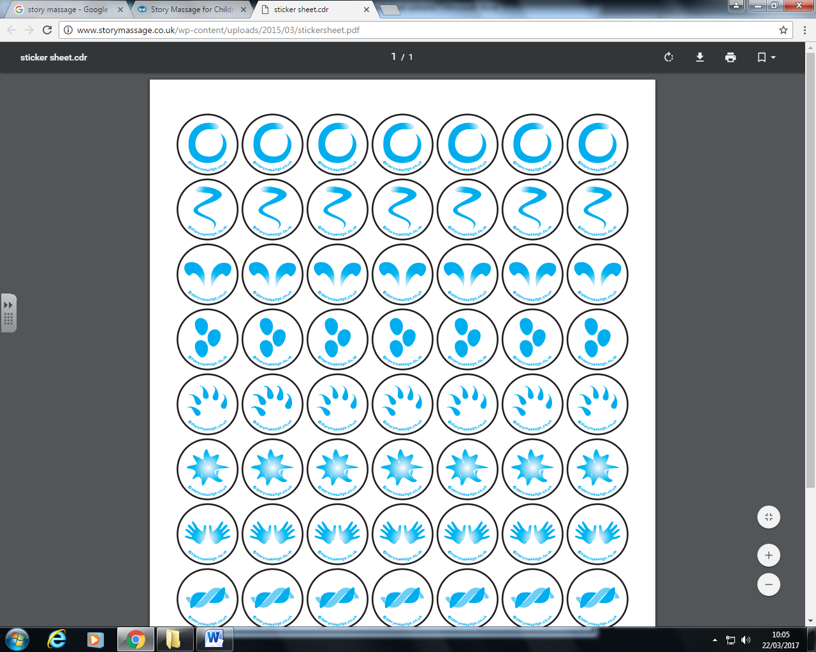  Wave | Once upon a time, there were three bears
Walk | A big bear  A medium bear  And a small bear
Calm | They were a happy family
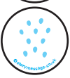  Sprinkle | Then along came Goldilocks
The Claw | She ate their porridge
The Claw | Broke the their chairs
The Claw | And slept in their bed
Circle | They said who are you?
Sprinkle | Goldilocks ran all the way home!

