Story Massage – Teddy Bears picnic
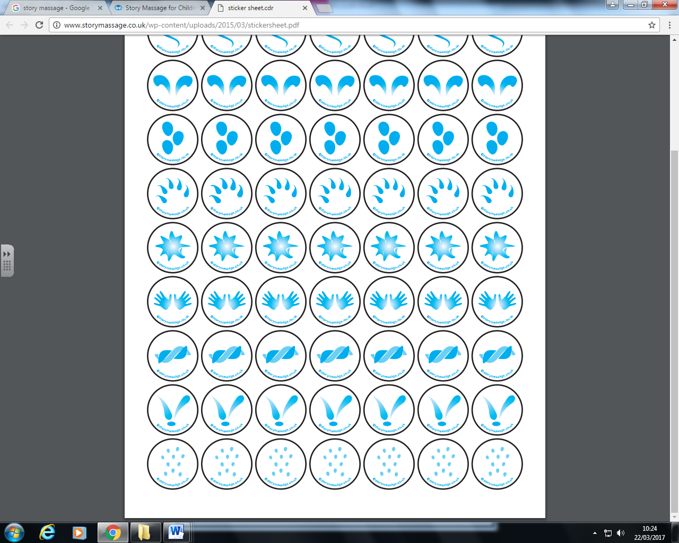  Sprinkle | If you go down in the woods today
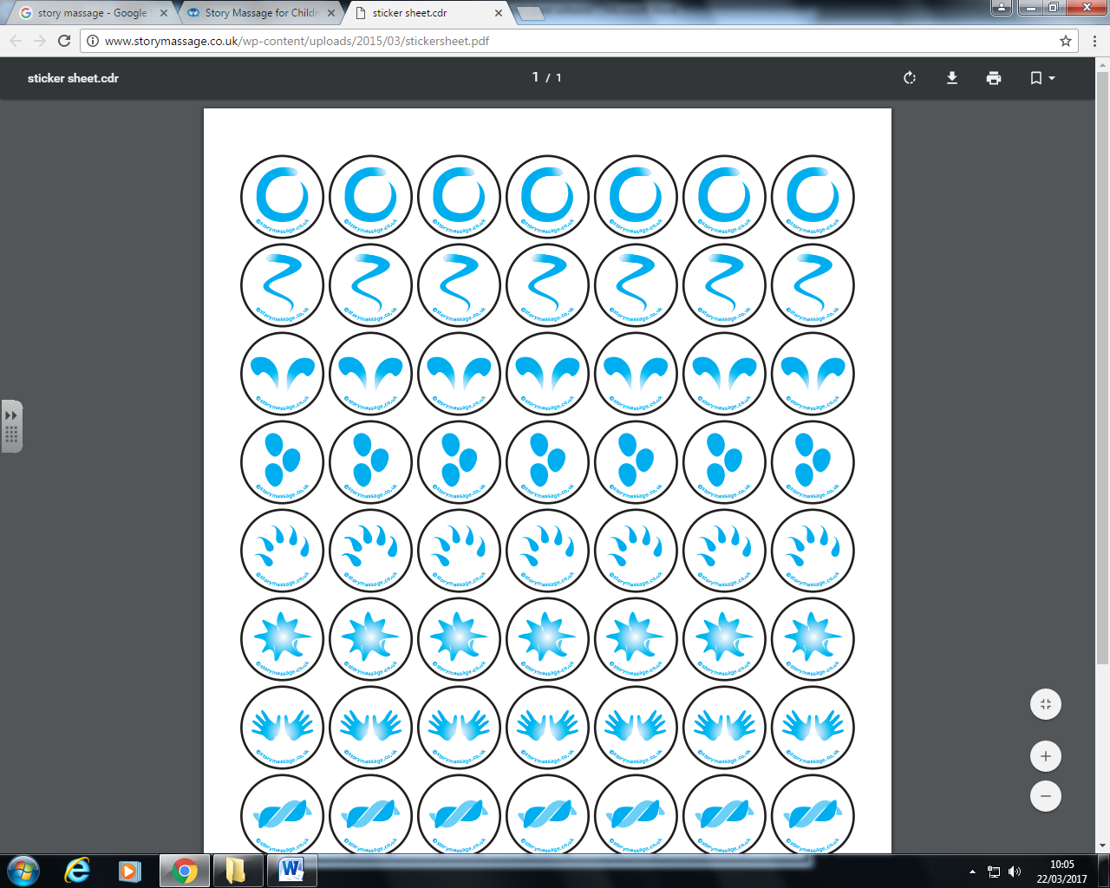  Wave | You're sure of a big surprise
Sprinkle | If you go down in the woods today
Wave | You'd better go in disguise!
Walk | For every bear that ever there was
Calm | Will gather there for certain
Walk | Because today's the day the
Calm | Teddy Bears have their picnic

