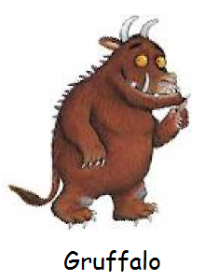

The Gruffalo Story Massage


A mouse took a stroll through the deep dark wood,

He found a nut and the nut was good.


But who is this creature with terrible claws,

and terrible teeth in his terrible jaws?


He has knobbly knees,

and turned out toes,


and a poisonous wart on the end of his nose!


His eyes are orange,

his tongue is black,

he has purple prickles all over his back!


Oh help! Oh no!

It’s a Gruffalo!

All was quiet in the deep dark wood.

A mouse found a nut and the nut was good.

