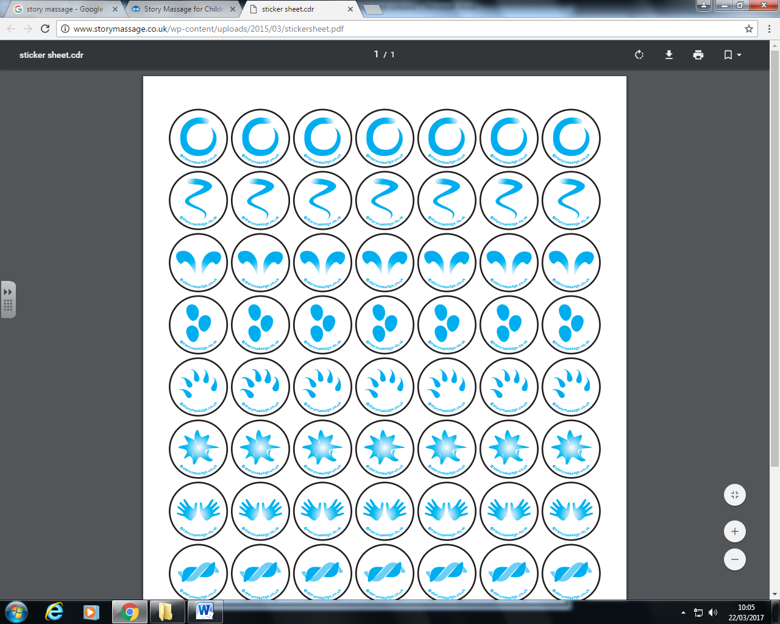
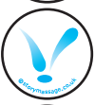

Come back Peter
Come back Paul.
Fly away Peter
Fly away Paul
One named Paul
One named Peter
Sat upon a wall
Two little dicky birds
Two little dicky birds

