When I need you, you are there

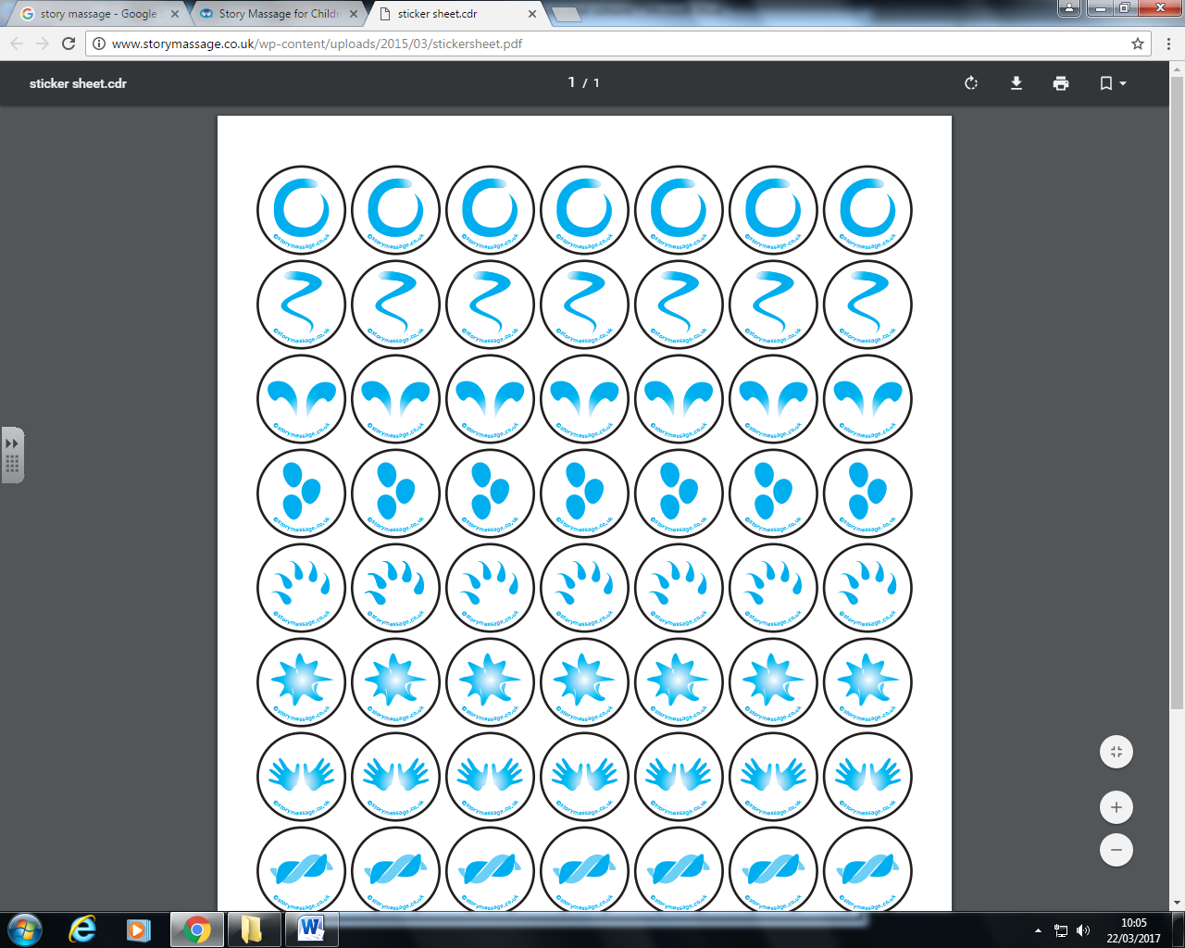
Twinkle, twinkle little star
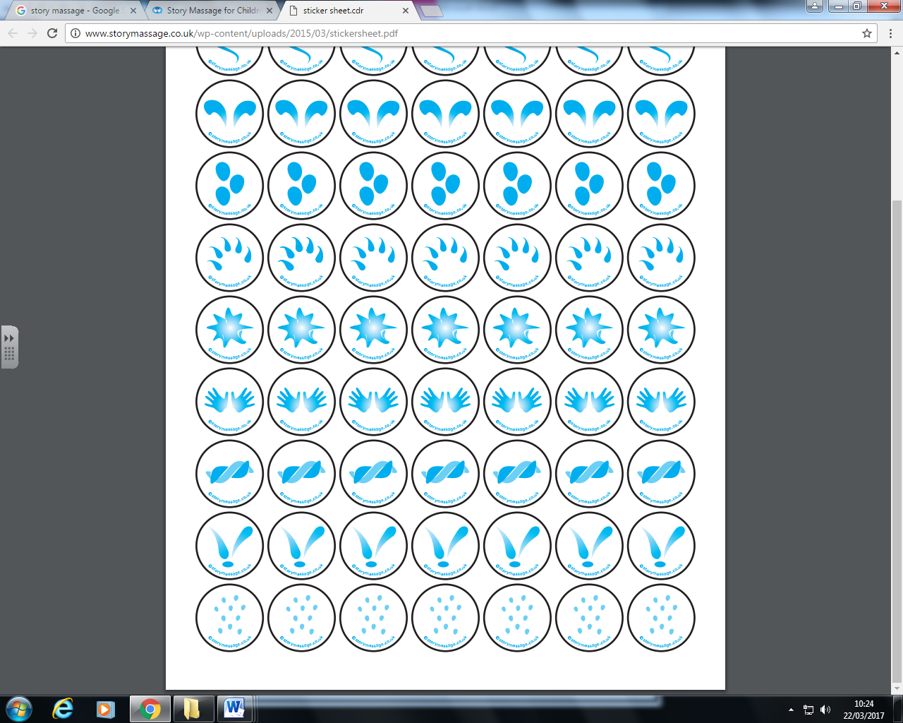
Happy Mother’s day!
Do you know how loved you are?
Twinkle, twinkle little star
Thank you so much for my care
You hug me and talk softly
Mummy, I know you love me
Do you know how loved you are?
Mummy do you know?

