SPRING IS COMING
Art and craft for kids is a great way to teach them about seasons. Here is a simple spring craft for our kids that also helps with recycling!
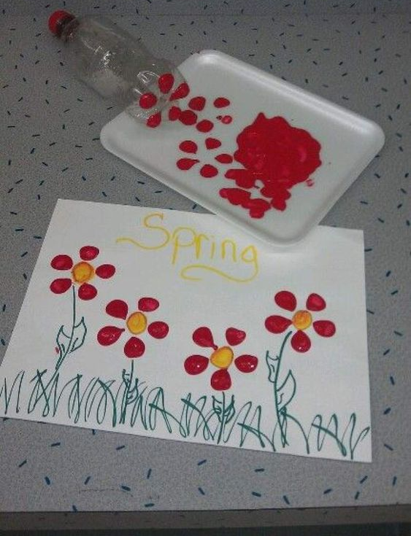
You will need:
- Red and yellow paint
- Empty plastic pop bottle
- Tray
- Card

Dip the bottom of the pop bottle into the red paint and print onto the card wherever you would like to make a flower. Use your child’s fingerprint to make the yellow centre of the flower!

