2 Ingredient Cloud-Dough: the ultimate sensory dough! Cloud dough requires only 2 common household ingredients, and it’s ready in minutes. It smells heavenly, and it’s a delight to run your fingers through!
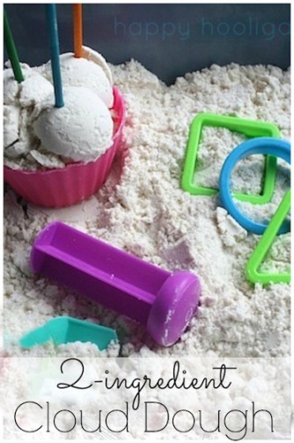
Cloud dough (also known as moon dough or moon sand) is silky and mold-able and takes just two ingredients to make. It’s an amazing sensory dough!
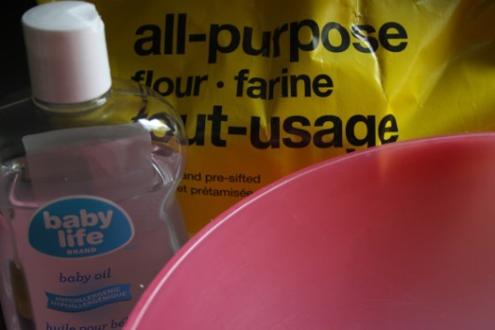

Cloud Dough Recipe:
Add one cup of baby oil to 8 cups of flour. Stir well (spoon or whisk is fine.)
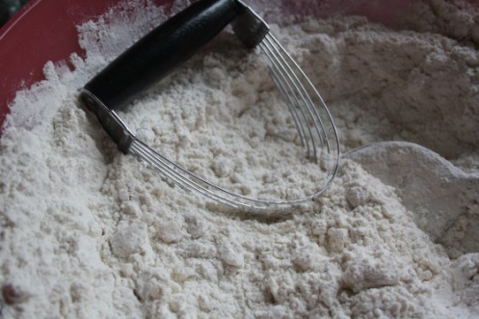
Transfer your dough to a bin or basin
Cloud dough will keep indefinitely when stored in a container with a lid.

