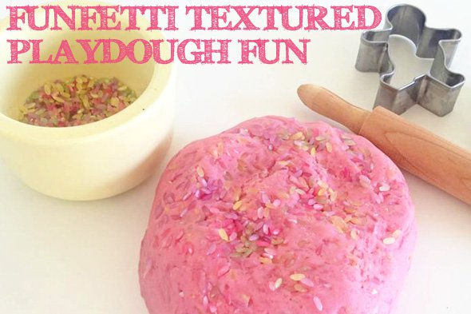

The addition of coloured rice to a basic playdough creates a rich, tactile experience.
To make:
Prepare your preferred homemade playdough according to the usual recipe

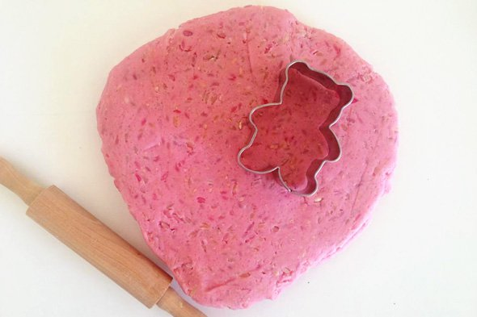
Once the playdough has completely cooled, knead 1 cup of multi-coloured rice into dough.
How to dye rice:

Simply place the rice into a bowl, add a few drops of liquid colouring and stir until the colour is evenly distributed. Add the colour a little at a time until the colour is built up to your preferred hue.
Then spread the rice out onto a lined baking tray to dry. It shouldn’t take long because you have hardly used any liquid to colour the rice, an hour at most and you’ll be done!


