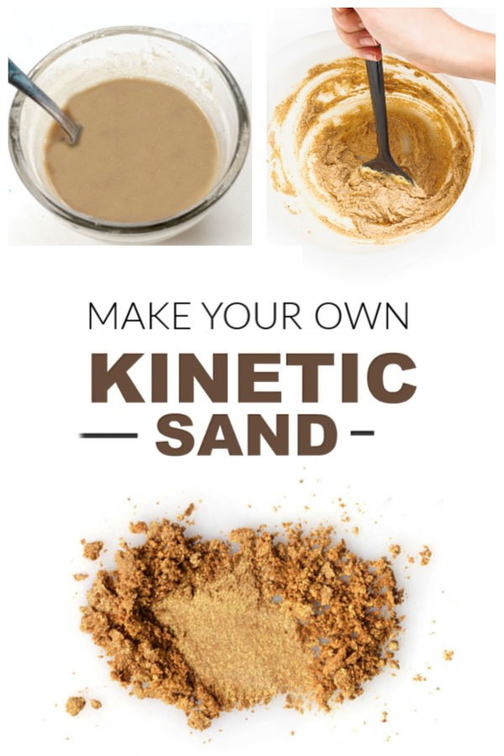

Kinetic Sand Recipe
- 1 cup of play sand
- 1/2 tbsp corn starch
- 1 tsp dish soap
- 1 cup of water (added as needed).
The dish soap in this recipe is what gives this sand a kinetic-like quality. It is so fun to squish and form into shapes in your hands.

Method
- Begin by combining the play sand and corn starch in a large bin or container.
- Mix well.
- In a separate container combine 1 cup of water with 1 tsp of dish soap and stir until the water is bubbly.
- Then, slowly add the water-mixture to the sand/cornstarch and mix well.
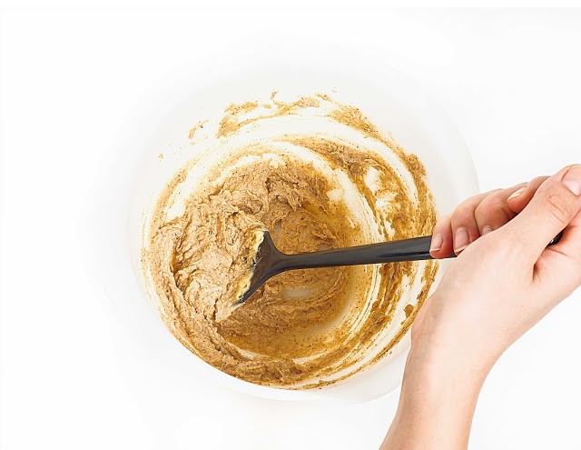
- Mix and mix, slowly adding more water & mixing as you go.
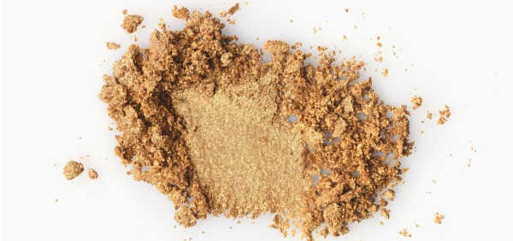
- Continue to add more water & mix until the desired consistency is reached.
That's it! Easy, right? And so fun!

