Homemade herb and spice playdough

This herb and spice play dough recipe uses natural flavours and scents to create an amazing sensory
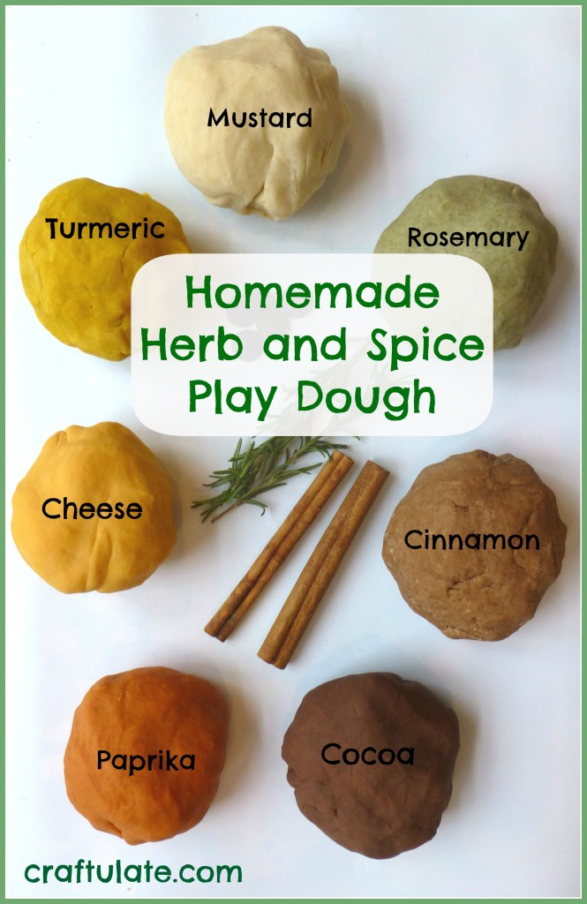
experience!

Spices used and suggested quantities
- Paprika - 1 tsp
- Cocoa Powder - 1-2 tbs
- Ground Turmeric Root - 1.5 tsp
- Mild Mustard Powder - 1-2 tbs
- Ground Rosemary - 2 tbs
- Cheddar Cheese Powder - 1 tbs
- Ground Cinnamon - 1 tbs

What you need
- ½ cup of plain flour
- ½ cup water
- 2 tbs salt
- 1 tsp cream of tartar
- Choice of herbs and spices
How to make the dough
- In a saucepan (preferably non-stick), on a low-medium heat, mix the first four ingredients together so the mixture is as smooth as possible. It is OK if a few little lumps remain. Add the spices and stir to mix thoroughly. Add more if needed.
- Heat slowly, stirring regularly. As the mixture starts to thicken, stir constantly. Soon it will begin to start to pull away from the sides of the saucepan and form one lump. This takes about five minutes.
- Remove from the heat and place the play dough ball on some parchment paper. Let cool and then knead for a minute or so.


