Mud Painting

Supplies for mud paint
- Food colouring or acrylic paint
- Water
- Cardboard
- Paint brushes
- Plastic containers
Directions
Add a large scoop of mud to each container then mix in paint or food colour to it. Do not need to measure, but approximately 1-2 tablespoons of each colour. Food colouring, acrylic paint, or even regular tempura paint can be used. Next you need to add a small amount of water and mix.

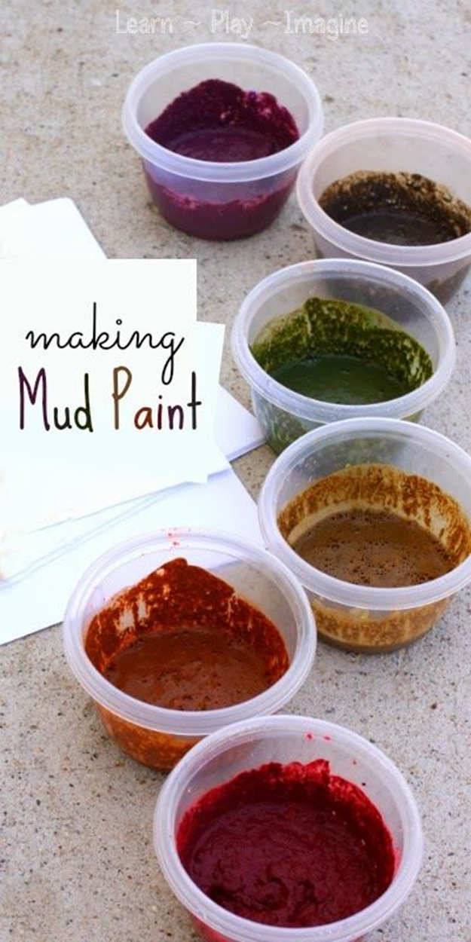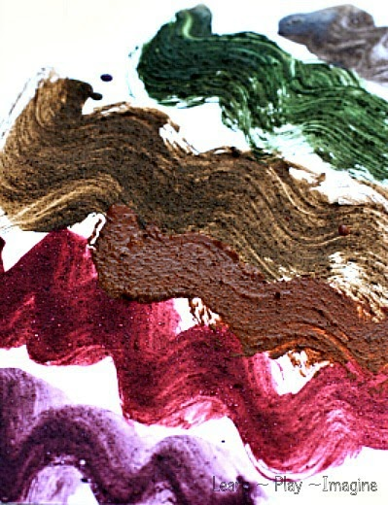

Activity
Use mud paint on cardboard to create earthy, textured paintings, experiment creating different colours, consistencies and organic, tactile landscapes such as forests, hills, mountains.
*Remember if you use acrylic paint, ensure it is not mouthed or stains clothes. Food colouring is the safer alternative.*

