PHONICS BALLS MATCHING GAME
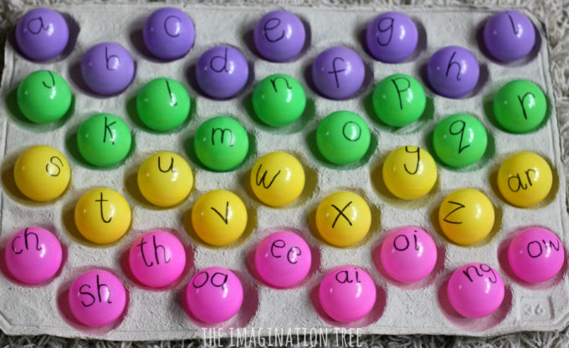

Materials needed:
Ball pit balls or Ping pong balls work too.
Empty fruit box packaging. (You can simply pick this up at the supermarket.)
Black Sharpie marker
Make the game
Write each letter of the alphabet, in lower case, onto the ball pit balls.
Write the corresponding sounds onto the fruit box packaging and then jumble all of the balls up in a large bowl or tray.
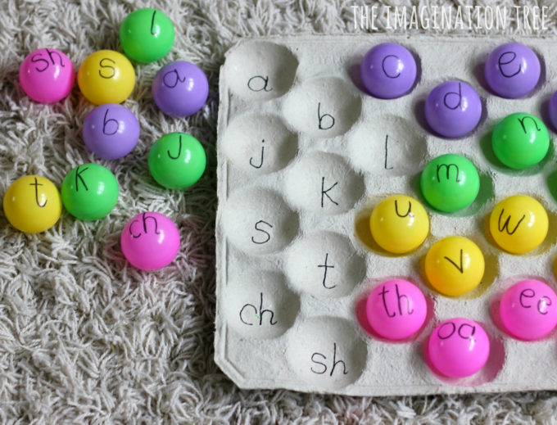

Ready to play!
Simply call out the sound you want your child to find and get them to identify it, SAY IT and then match it!
This first stage may seem super simple but it’s critical as it helps consolidate recognition of the letter sound correspondences. If they find this enough of a challenge then leave the fame here and come back to practise it again the next day and so on until they can find, say and identify those sounds super quickly.
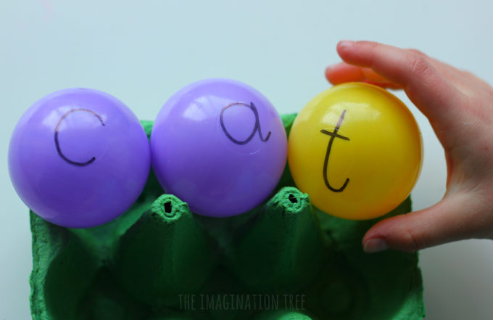
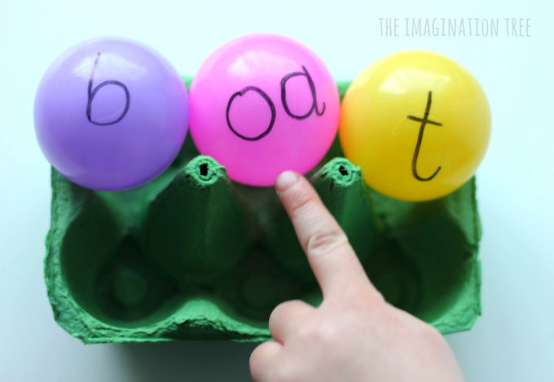
Equally, if your child is ONLY JUST starting out with phonics learning then limit this activity to just 3-6 sounds to begin with. It will most likely begin with letter sounds. You could also use the balls to spell out their name!

