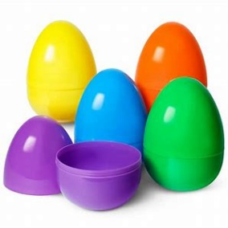
Textured Eggs
Contents:
6 plastic eggs
Rice/pasta/beads etc. to fill the eggs
Hot glue gun/ strong glue

Pipe cleaners
Feathers
Buttons
String


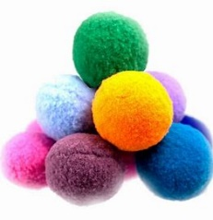
Sequins
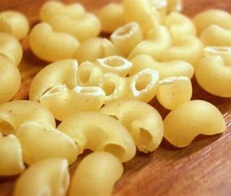
Tinsel
Pom-poms
Felt
Leather
(Anything you want to use to cover the eggs)
Method:
1. Open up the plastic eggs and put anything in you think will create an interesting sound, e.g. rice, pasta, beads etc.
2. Don't fill them up fully, allow space for the contents to move when shaken.
3. Using the glue gun or strong glue, seal the eggs back together and wait for the glue to set.
4. Choose what you are going to use to decorate the eggs, the more interesting the texture of the decoration, the better.
5. Above are some suggestions of decoration, but it is really up to you what you choose.
6. Stick whatever you choose to the plastic egg using the strong glue to ensure It doesn't come off.

