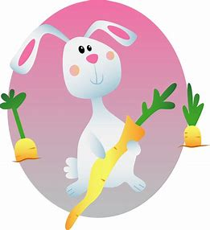
Story Massage
Easter Bunny Hippity Hop

Poem | Action | Instruction
Easter bunny |  | The fan  With both palms flat, start with hands at the centre together and move up and out (away from each other) to create a fan shape
Hippity hop |  | The bounce  Use one hand at a time to gently ‘squeeze’ and pick up the area and then release upwards.
Hide ‘til Easter morning |  | The wave  With your palm flat, draw a vertical wavy line
Easter bunny |  | The fan  With both palms flat, start with hands at the centre together and move up and out (away from each other) to create a fan shape
Hippity hop |  | The bounce  Use one hand at a time to gently ‘squeeze’ and pick up the area and then release upwards.
Wake up the day is dawning! |  | The wave  With your palm flat, draw a vertical wavy line

