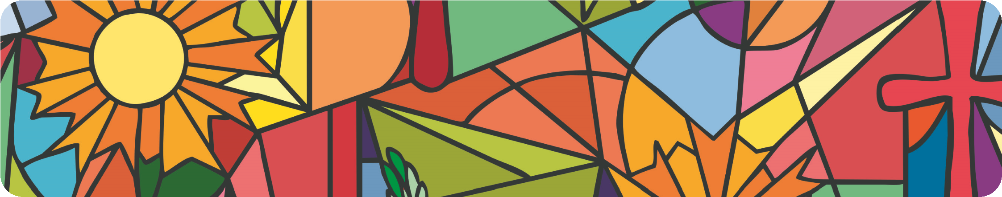
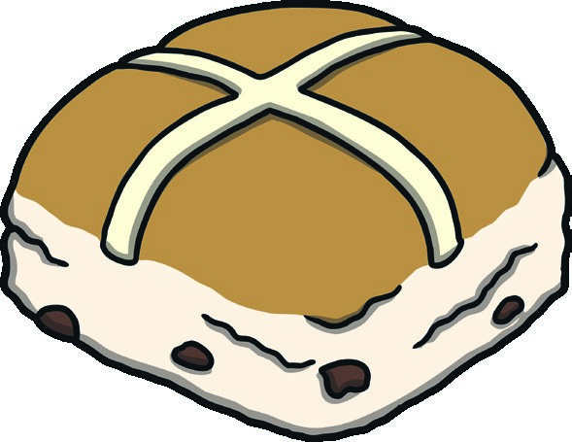
flour 50g caster sugar
Ingredients
500
g strong, white bread
Hot Cross Buns
Riley’s favourite Easter breakfast treat!
Method
1
.
Mix the bread flour, salt, mixed spice and sugar.
50g butter, cubed
200g dried mixed fruit
7g sachet of easy-blend, dried yeast 200ml milk
2 eggs
- heaped tsp mixed spice½ tsp salt
To decorate
- tbsp plain flour
2 tbsp water
Honey or golden syrup
Equipment Oven
2 mixing bowls
Measuring jug
Fork or whisk for beating
Blunt knife
Baking sheet
Cling film
Piping bag
Pastry brush
- Rub in the butter using your fingertips and stir in the dried fruit.
- Sprinkle the yeast over the mix and stir.
- Carefully, warm the milk and beat this with the eggs. Then, add the dry ingredients.
- Mix the ingredients until they form a moist dough and leave for 5 minutes.
- Remove the dough from the bowl and cut it into 8 equal pieces.
- Shape each piece into a bun and place on a floured surface. Then, place them on a baking sheet. Cover them loosely with cling film and leave in a warm place until they have grown about 50% bigger (anywhere between 45 minutes and 1 ½ hours).
- When they have risen, mix the flour with the water until it forms a paste. This will make the cross decoration on top.
- Put the paste into a piping bag. Pipe crosses on top of each bun.
- Bake for 12 –15 minutes until golden. Brush the honey or golden syrup over the top.
- Enjoy warm or toasted with butter!
Makes approx. 8 hot cross buns.

