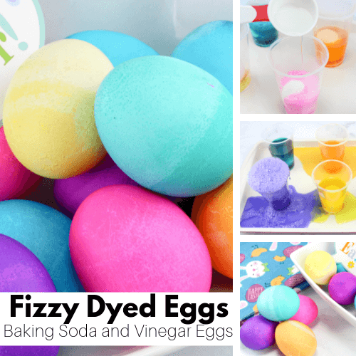

YOU WILL NEED:
Hard boiled Eggs White Vinegar Baking Soda
Food Colouring (Assorted Colours) Disposable Cups
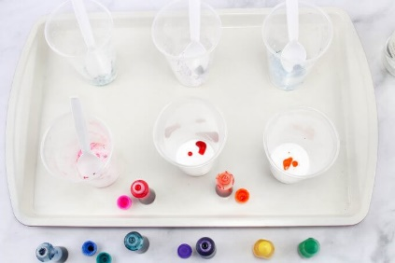
1: Place ½ Tablespoon of baking soda into each cup. Add 5-6 drops of food colouring to each cup and mix with a spoon.

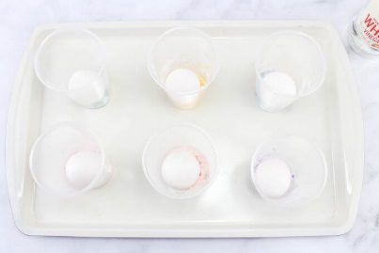
2: Place one hard boiled egg into each cup. Place cups on a sheet pan or 9×13 pan.

3: Pour 1/3 cup of vinegar into each cup and watch it bubble up! There might be some spillage so make sure the cups are on a pan. Add more vinegar if you want to watch it bubble up again. Have fun! 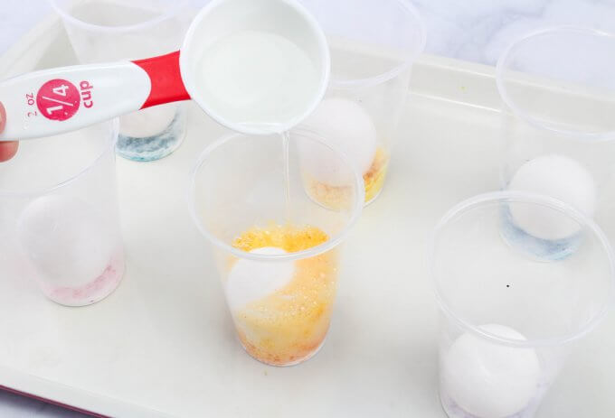

4: Let sit for 5-10 minutes, take out and set on paper towels to dry. The colours will be super vibrant and colourful!


