






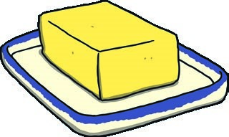

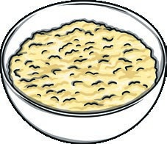


45g brown sugar
Ingredients
Easter Flapjack
Method
145g butter
60g golden syrup
215g rolled oats
200g milk or dark chocolate or a mixture of both 1 tbsp vegetable oil
1 x 89g bag of mini creamfilled chocolate eggs or 1 x 80g bag of sugar-coated chocolate mini eggs
Equipment
Large pan
20cm² baking tin lined with non-stick baking parchment
Wooden spoon
Glass bowl
Small saucepan
Microwave (optional)
- Wash your hands and put on an apron.
- Preheat the oven to 180°C, Gas Mark 4.
- Melt the sugar, syrup and butter in a large pan until melted, bubbly and caramel in colour.
- Turn off the heat and add the oats, stirring well until everything is combined.
- Press the mixture firmly into the prepared baking tin and bake for 20-25 minutes until lightly golden on top.
- Remove from the oven and set aside to cool.
- Meanwhile, melt the chocolate in a bowl over a small saucepan filled with simmering water. Alternatively, melt the chocolate by placing the bowl in the microwave for short 20-30 second bursts on a medium setting. Be careful, as chocolate burns easily if overheated
- Spread the melted chocolate over the top of the cooled flapjack.
- Decorate with whole sugar-coated eggs or cream-filled eggs sliced in half (this is easier to do if you have placed them in the fridge beforehand). Alternatively, open the bag of sugar-coated eggs slightly and bash with a rolling pin, then sprinkle the smashed-up eggs over the top of your flapjack.
- When completely cool, remove from the tin and slice before serving.

To make the recipe vegan, simply replace the butter and chocolates with a vegan substitute.

