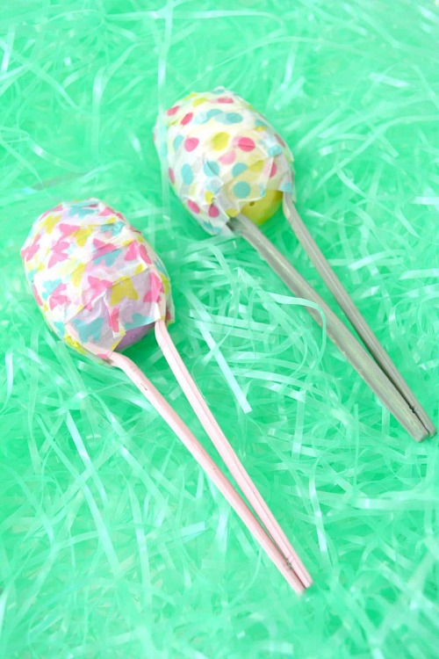
Easter Egg Maracas

You will need:
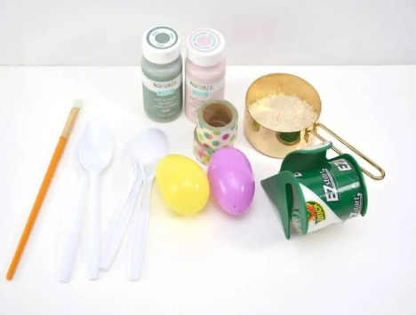
Patterned tape in Easter / Spring colours
Plastic Easter eggs
Plastic spoons
Craft paint & paintbrush (optional)
Rice, beans, beads, or other small items

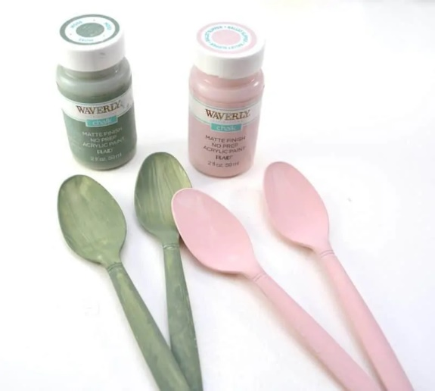
- Paint the plastic spoon

- Fill the plastic eggs with rice, beans, lentils or other small items to make a sound when you shake the plastic eggs.
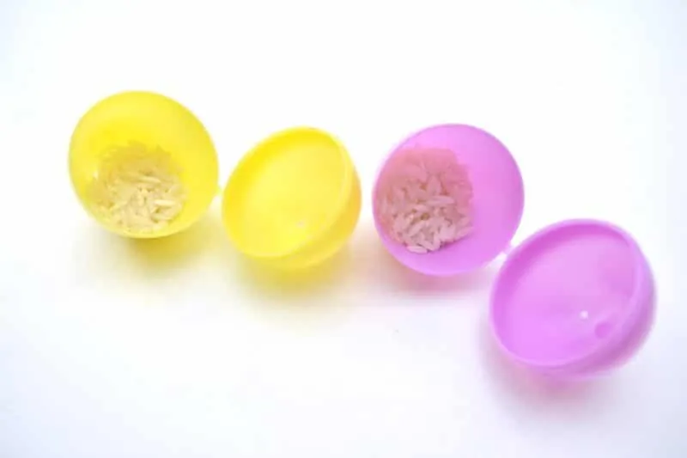

- Use tape to seal the eggs.
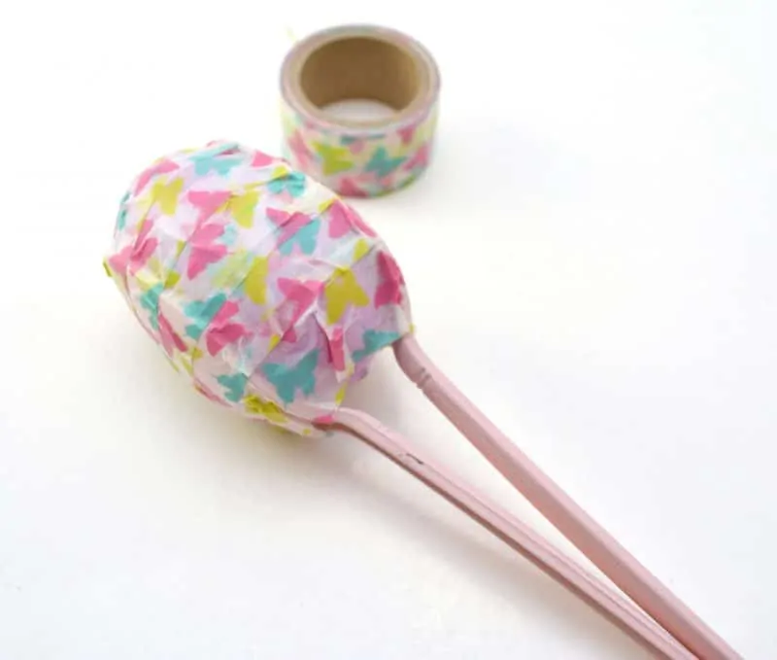
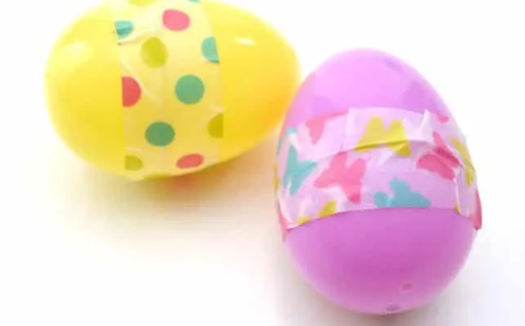
4. Once the spoons have dried completely, face 2 spoons towards each other with your filled plastic egg between them. Use the tape to seal them together and shake your egg maraca!

