

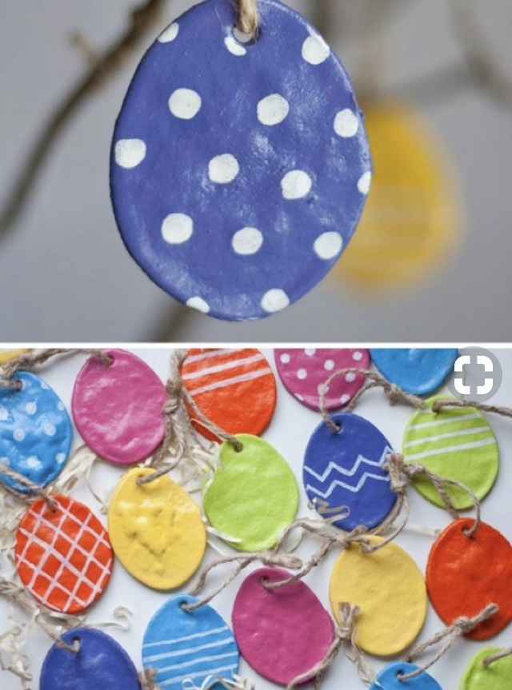
Follow the recipe to make salt dough. Roll out flat and cut into oval shapes for eggs.
Make sure to create a hole at the top for hanging later.
Ensure salt dough is fully dry before painting/decorating with glitter.
Thread ribbon through the top to dangle your eggs!

