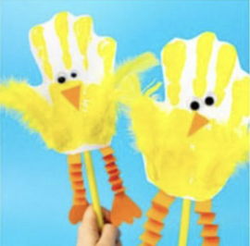
Handprint Chicks

You will need:
- Yellow paint
- Yellow feathers
- Orange triangle card
- Long strip of card for legs and feet
- Googly eyes
- Lollypop stick
Method:
- Paint hand yellow, print onto card and wait to dry.
- Attach yellow feathers with glue on the thumb and little finger prints for wings.
- Attach triangle for beak and googly eyes for face.
- Fold long strips of orange card back and for to create concertina legs.
- Glue lollypop stick to base of chick.

