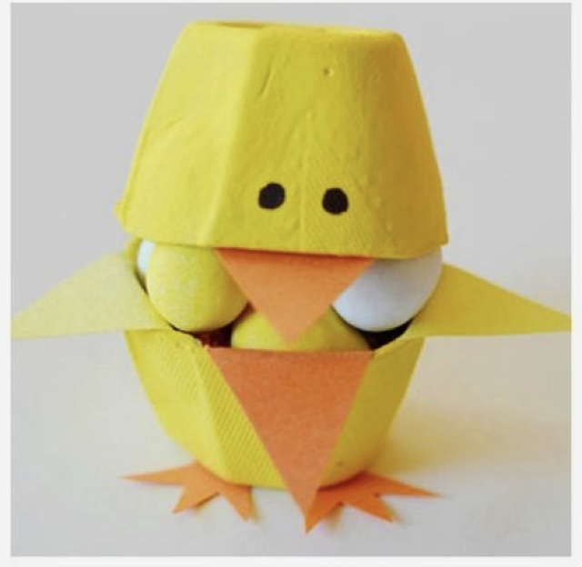
Easter Egg Box Chick
You will need:
- Cardboard egg box
- Yellow paint
- Orange card
- Chocolate eggs
Instructions:
- Cut the cardboard egg boxes to create bases and lids, leaving the back attached so that they open and shut from the front.
- Paint the egg box yellow.
- Attach the orange triangles as wings either side of the base and a beak at the top.
- Cut three points and attach at the base to make feet.
- Draw eyes and fill with chocolate eggs!


