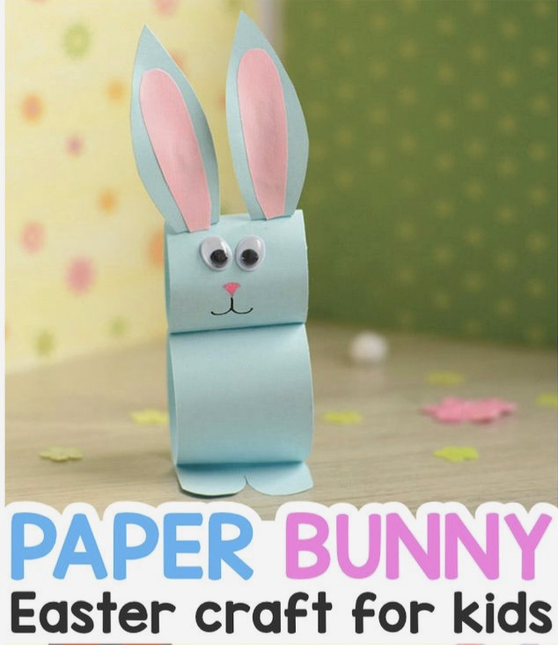
Bunny Easter craft
You will need:
- Kitchen rolls/card
- Paint
- Glue
- Googly eyes
- Coloured pens

Method:
- Cut the kitchen roll into sections and use two parts/roll card to create two cylinders.
- Paint the rolls and when dry glue together.
- Attach ears and feet (see templates)
- Attach googly eyes and draw face


