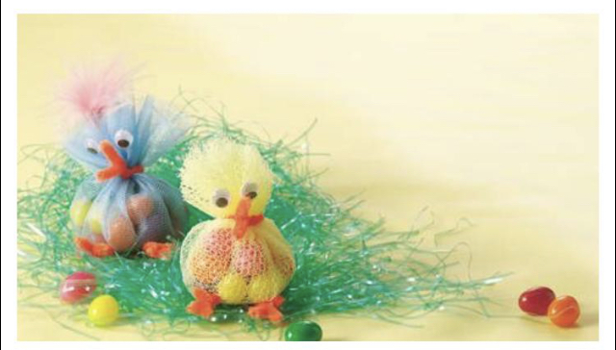
Chocolate chicks
You will need:
- Netting
- Orange pipe cleaners
- Googly eyes
- Small chocolate eggs

Instructions:
- Cut the netting into a circle.
- Place the chocolate eggs inside.
- Tie at the top with orange pipe cleaner leaving the ends loose to form the beak of the chick.
- Twist the bottom pipe cleaners into a cross shape, placing the longest part of the cross through the bottom of the netting so that the three sections are at the front to form feat.
- Place the googly eyes at the top and pass on to someone you love for an Easter treat!

