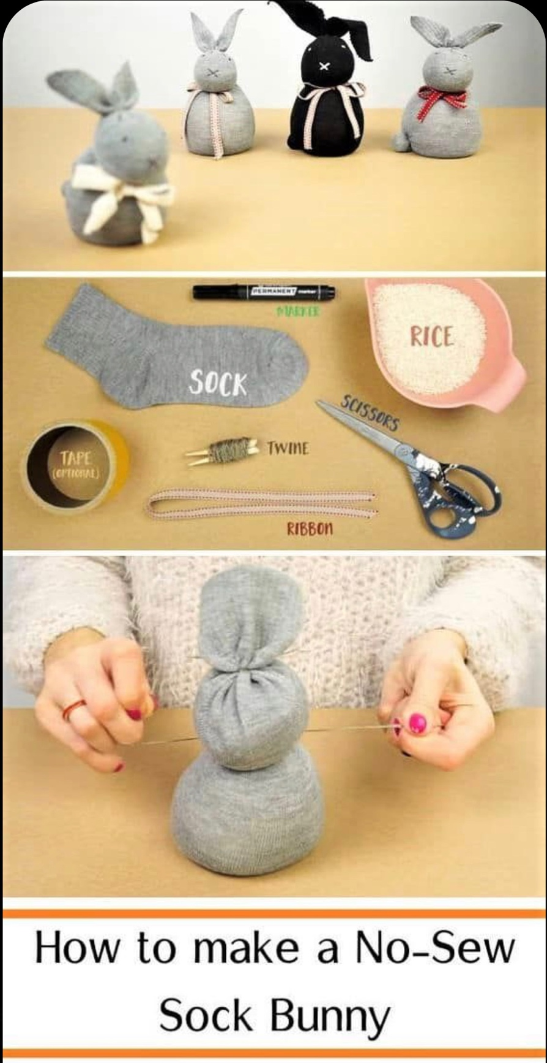
Sock Bunny

You will need:
- Sock
- Scissors
- Rice
- String or elastic band
- Ribbon
- Marker

To make:

Fill the bottom half of the sock with rice and use the string to tie to create the rabbits’ body.

Fill the next part of the sock to create the rabbits head and tie.

Cut the top of the sock into two to create two floppy ears.

Draw eyes nose and mouth on bunny and tie a ribbon around the neck.

Now you have a beautiful Easter Bunny!

