Activity 5- Pictures to print to use for activity

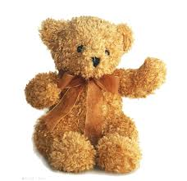
Teddy
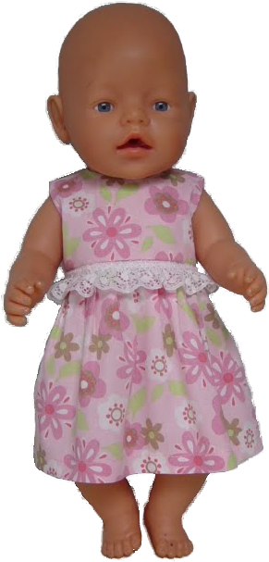
Dolly

