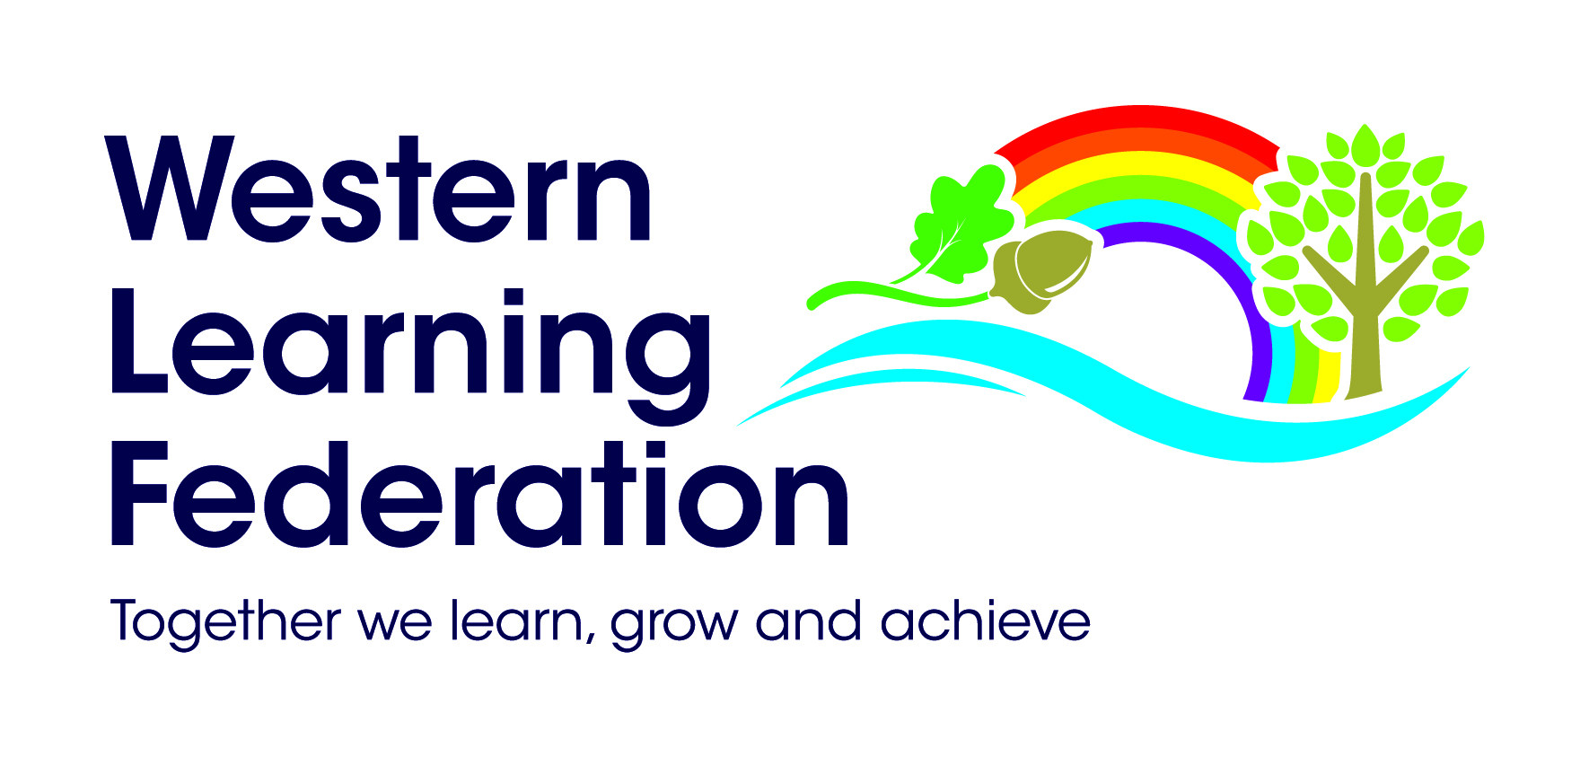
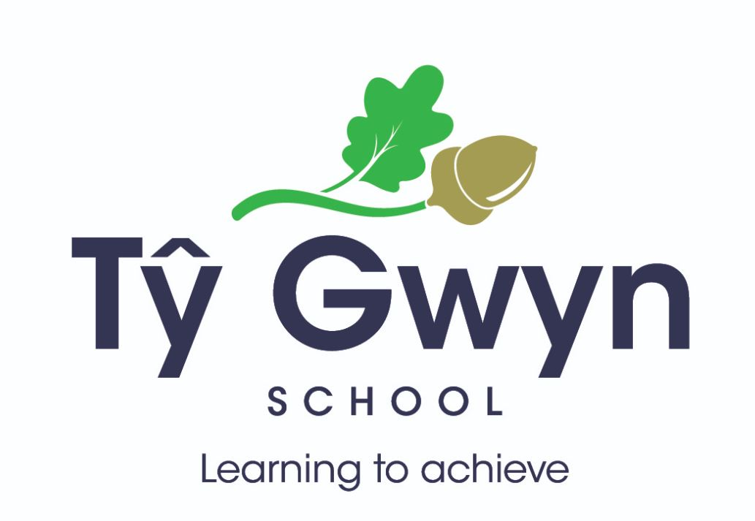
In Partnership with   & 

Five Day Course for Intervenors

This is the original Intervenor Course developed and delivered by Jenny Fletcher and colleagues with extensive experience of MSI. The 5-day course is specifically designed for Teaching Assistants, Health Care Workers, Learning Support Workers, Social Care Workers and those employed to work on a 1:1 basis with a child or young person who is congenitally multi-sensory impaired / deafblind, or has a single sensory impairment with additional complex needs.

This course meets the requirements of the Intervenor Standards issued by NatSIP

For more information, please contact: Robert Monteith

Email: Robert.Monteith2@cardiff.gov.uk Tel : 02920 838560

Upon successful completion of this five- day Course, participants will receive a “Certificate of attendance” and are a Trained Intervenor.

University of Northampton in collaboration with NatSIP will be providing the option of accreditation at Level 4 worth 20 CATS (Credit Accumulation Transfer System) points in ‘Supporting Learners who are Deafblind/ Multi-Sensory Impaired’
Cost of Accreditation = £365
Monday 18th – Friday 22nd November 2024
At Ty Gwyn School, Vincent Rd, Ely, Cardiff, CF5 5AQ
£475 per participant

Course content includes: -
- Implications of MSI
- The Role of the Intervenor
- Vision
- Hearing
- Functional Assessment
- Sighted Guide Practice
- Communication
- Touch Interaction
- Learning Environments

