
Children’s Centre
Canolfan I Blant
Paediatric Physiotherapy Department
St David’s Hospital Ysbyty Dewi Sant
CF11 9XB

Tel: 02921 836802

Cowbridge Road East Cowbridge Road East
Canton Treganna
Cardiff Caerdydd
CF11 9XB CF11 9XB
Phone 029 20536802 FfÔn 029 2053 6802
Fax 029 2053 6779 Ffacs 029 2053 6779

Animal Moves

Bear Walking
Walk on your hands and feet with your legs straight. Make your body look heavy and wide.
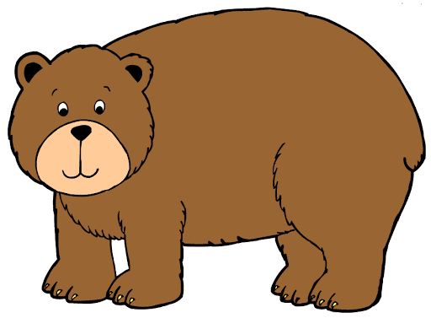

Giraffe Walking
Walk on your tip toes to be as tall as you can. Stretch your body and neck too.
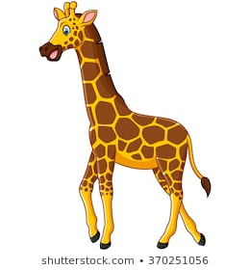

Children’s Centre
Canolfan I Blant
Paediatric Physiotherapy Department
St David’s Hospital Ysbyty Dewi Sant
Cardiff
CF11 9XB

Tel: 02921 836802

Cowbridge Road East Cowbridge Road East
Canton Treganna
Cardiff Caerdydd
CF11 9XB CF11 9XB
Phone 029 20536802 FfÔn 029 2053 6802
Fax 029 2053 6779 Ffacs 029 2053 6779

Hippo Walking
Make your body wide and your feet flat and heavy. Can you take heavy steps like a hippo?


Quiet as a mouse
Can you creep around like a mouse? Be quiet and very fast.
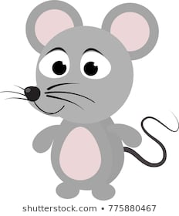

Children’s Centre
Canolfan I Blant
Paediatric Physiotherapy Department
St David’s Hospital Ysbyty Dewi Sant
Cardiff
CF11 9XB

Tel: 02921 836802

Cowbridge Road East Cowbridge Road East
Canton Treganna
Cardiff Caerdydd
CF11 9XB CF11 9XB
Phone 029 20536802 FfÔn 029 2053 6802
Fax 029 2053 6779 Ffacs 029 2053 6779

Jump like a frog
Can you push off your hands and feet and jump high like a frog.
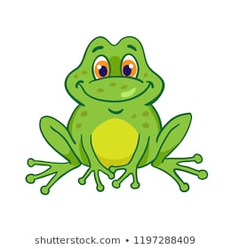

Walk like an elephant
Can you move slowly and take big steps like an elephant.


Children’s Centre
Canolfan I Blant
Paediatric Physiotherapy Department
St David’s Hospital Ysbyty Dewi Sant
Cardiff
CF11 9XB

Tel: 02921 836802

Cowbridge Road East Cowbridge Road East
Canton Treganna
Cardiff Caerdydd
CF11 9XB CF11 9XB
Phone 029 20536802 FfÔn 029 2053 6802
Fax 029 2053 6779 Ffacs 029 2053 6779

Jump like a rabbit
Can you put your hands and feet on the floor and jump forwards using your feet and land using your hands first and then your feet.
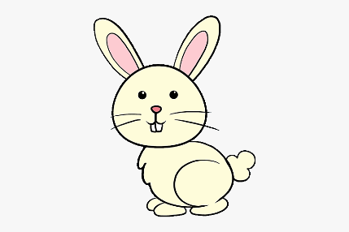

Slithering snake
Can you lie on your tummy on the floor and slither along the floor like a snake? You must keep your body as close to the floor as possible.


