
Children’s Centre
Canolfan I Blant
Paediatric Physiotherapy Department
St David’s Hospital Ysbyty Dewi Sant
Cardiff
CF11 9XB

Tel: 02921 836802

Cowbridge Road East Cowbridge Road East
Canton Treganna
Cardiff Caerdydd
CF11 9XB CF11 9XB
Phone 029 20536802 FfÔn 029 2053 6802
Fax 029 2053 6779 Ffacs 029 2053 6779

Balance
Single leg stand-
Stand on one leg for as long as possible and alternate leg throughout.
Progression = Try this with your eyes closed
Regression = Hold onto something for support
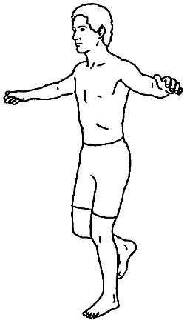

Standing with feet together-
Stand with your feet close together and hold it for as long as possible.
Progression= Try this with your eyes closed/ or try a tandem stand.
Regression= Stand with feet slightly apart.


Children’s Centre
Canolfan I Blant
Paediatric Physiotherapy Department
St David’s Hospital Ysbyty Dewi Sant
Cardiff
CF11 9XB

Tel: 02921 836802

Cowbridge Road East Cowbridge Road East
Canton Treganna
Cardiff Caerdydd
CF11 9XB CF11 9XB
Phone 029 20536802 FfÔn 029 2053 6802
Fax 029 2053 6779 Ffacs 029 2053 6779

Tandem walking-
Walk in a straight line, try to ensure that your heel and toes touch between each step.
Progression= Standing still with one foot directly in front of the other playing catch
Regression= Take bigger steps leaving a gap between your heel and toe.
Regression= Hold onto a wall for support.
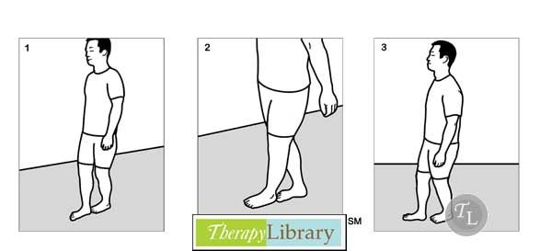

Hopscotch
Hopping and star jumping from number to number.


Children’s Centre
Canolfan I Blant
Paediatric Physiotherapy Department
St David’s Hospital Ysbyty Dewi Sant
Cardiff
CF11 9XB

Tel: 02921 836802

Cowbridge Road East Cowbridge Road East
Canton Treganna
Cardiff Caerdydd
CF11 9XB CF11 9XB
Phone 029 20536802 FfÔn 029 2053 6802
Fax 029 2053 6779 Ffacs 029 2053 6779

Stream Jumping-
Place two lines on the floor, pretending that there is a stream in the middle, encourage your child to jump over the stream and land with 2 feet.
Progression= Increase the distance between the lines.
Regression= Decrease the distance between the lines.

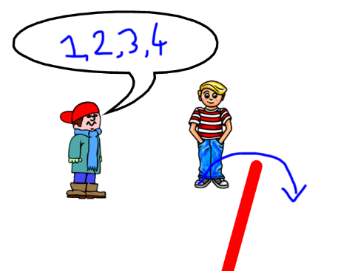

Cushion walking-
Walk along cushions or uneven surfaces, try to keep yourself upright.
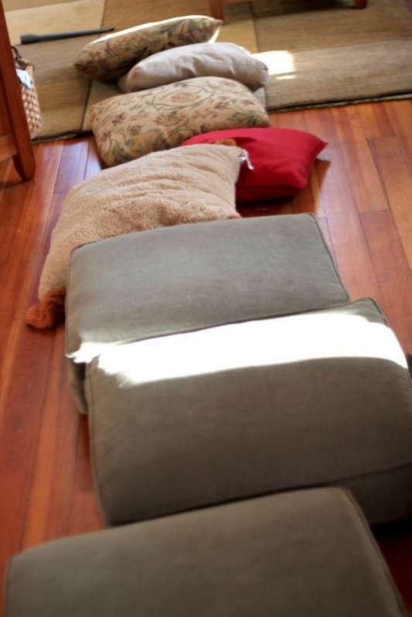

Children’s Centre
Canolfan I Blant
Paediatric Physiotherapy Department
St David’s Hospital Ysbyty Dewi Sant
Cardiff
CF11 9XB

Tel: 02921 836802

Cowbridge Road East Cowbridge Road East
Canton Treganna
Cardiff Caerdydd
CF11 9XB CF11 9XB
Phone 029 20536802 FfÔn 029 2053 6802
Fax 029 2053 6779 Ffacs 029 2053 6779

½ kneeling –
Go up into a high kneeling position, put 1 leg forwards staying in a high kneeling position. Encourage your child to keep their balance in the midline, making sure they stay on their knees.
You can play throw and catch in this position
Reach to your side to challenge balance
Progression= Bring your leg closer towards your body,
Regression = take your leg out to the side slightly to increase the base of support.
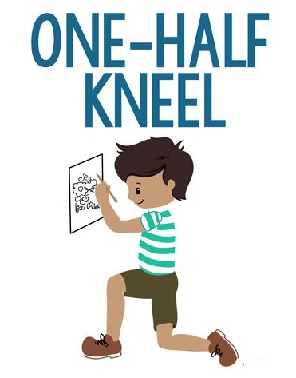

In this position reach out to the side, up and down to challenger your balance. The further you reach the harder it will be to control your balance.

