
Children’s Centre
Canolfan I Blant
Paediatric Physiotherapy Department
St David’s Hospital Ysbyty Dewi Sant
Cardiff
CF11 9XB

Tel: 02921 836802

Cowbridge Road East Cowbridge Road East
Canton Treganna
Cardiff Caerdydd
CF11 9XB CF11 9XB
Phone 029 20536802 FfÔn 029 2053 6802
Fax 029 2053 6779 Ffacs 029 2053 6779

Core

Superman (Hip extension)

Start in a 4 point kneeling position, kick 1 leg out behind you and repeat with the other leg. Repeat 10x, try to make sure that your back and arms are straight throughout.
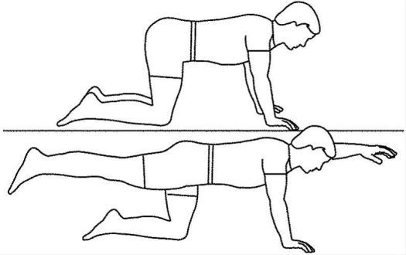

Regression= If it is too hard to keep straight arms then, you can lean on your forearms instead.

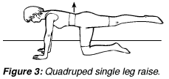

Superman (Arm extension)

Start in a 4 point kneeling position, reach out with 1 arm and repeat this with the other. Attempt to do this 10x, make sure that you keep your back straight throughout.

Regression= If it is too hard to keep straight arms then, you can lean on your forearms instead.

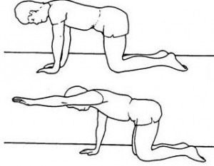

Children’s Centre
Canolfan I Blant
Paediatric Physiotherapy Department
St David’s Hospital Ysbyty Dewi Sant
Cardiff
CF11 9XB

Tel: 02921 836802

Cowbridge Road East Cowbridge Road East
Canton Treganna
Cardiff Caerdydd
CF11 9XB CF11 9XB
Phone 029 20536802 FfÔn 029 2053 6802
Fax 029 2053 6779 Ffacs 029 2053 6779

Bridge-

Lie on your back arms down by your side, bend your knees and lift your bottom up. Make sure that you are pushing through your legs and not your shoulders. You can pass a toy underneath your bottom example a train through the tunnel.

Regression= Put your hands underneath your bottom to help with the lift.

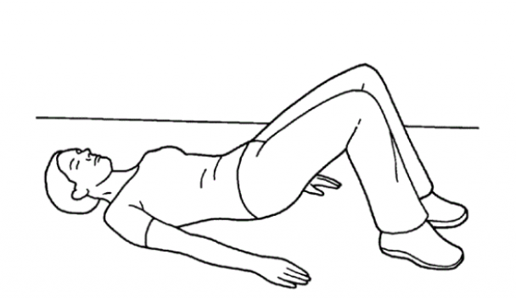

Clams-

Lie on your side, bend both of your knees, and lift the top towards the ceiling whilst keeping the bottom leg on the floor. Try to ensure that you do not lean backwards and keep your trunk in midline.
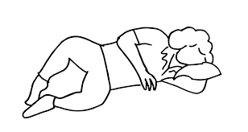

Children’s Centre
Canolfan I Blant
Paediatric Physiotherapy Department
St David’s Hospital Ysbyty Dewi Sant
Cardiff
CF11 9XB

Tel: 02921 836802

Cowbridge Road East Cowbridge Road East
Canton Treganna
Cardiff Caerdydd
CF11 9XB CF11 9XB
Phone 029 20536802 FfÔn 029 2053 6802
Fax 029 2053 6779 Ffacs 029 2053 6779

Wheelbarrow-

Put your hands down, keep your elbows straight and somebody holding onto your ankles walk forwards and backwards.

Try to keep your back straight throughout.

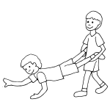

Hip flexion (knee raise)

Stand up, lift your knee towards the ceiling and repeat as many times as possible, alternate each leg.

Progression= increase the speed and amount of reps.

Regression= Try this lying down to eliminate gravity/ or hold onto a chair to help with balance.

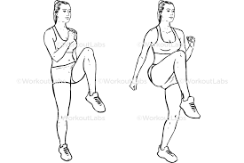

Children’s Centre
Canolfan I Blant
Paediatric Physiotherapy Department
St David’s Hospital Ysbyty Dewi Sant
Cardiff
CF11 9XB

Tel: 02921 836802

Cowbridge Road East Cowbridge Road East
Canton Treganna
Cardiff Caerdydd
CF11 9XB CF11 9XB
Phone 029 20536802 FfÔn 029 2053 6802
Fax 029 2053 6779 Ffacs 029 2053 6779

Cycling-

Encourage your child to cycle as much as possible.



Swimming-

Encourage your child to go swimming as often as possible, this will strengthen them all round.


Prone play-
Encourage your child to play in prone 74on their tummy). Make games fun and interactive as possible, i.e. reaching, singing, and drawing.
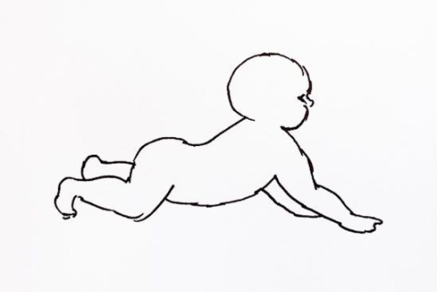

Children’s Centre
Canolfan I Blant
Paediatric Physiotherapy Department
St David’s Hospital Ysbyty Dewi Sant
Cardiff
CF11 9XB

Tel: 02921 836802

Cowbridge Road East Cowbridge Road East
Canton Treganna
Cardiff Caerdydd
CF11 9XB CF11 9XB
Phone 029 20536802 FfÔn 029 2053 6802
Fax 029 2053 6779 Ffacs 029 2053 6779

Climbing-

Allow your child to climb up and down different sized equipment in the house but only if safe to do so. For example up a step, over a cushion, step over a ball. Try to make this as fun as possible.


Frog jumping-

Try and jump like a frog. Push up through your arms and jump landing with 2 feet on the ground if possible.

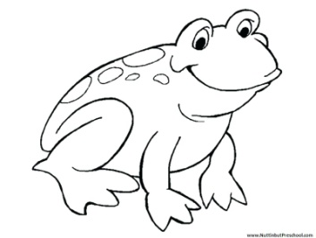

Squat-

Make sure your feet are shoulder width apart, squat as far as you can go, ensure that you try to keep your back straight.



