
Children’s Centre
Canolfan I Blant
Paediatric Physiotherapy Department
St David’s Hospital Ysbyty Dewi Sant
Cardiff
CF11 9XB

Tel: 02921 836802

Cowbridge Road East Cowbridge Road East
Canton Treganna
Cardiff Caerdydd
CF11 9XB CF11 9XB
Phone 029 20536802 FfÔn 029 2053 6802
Fax 029 2053 6779 Ffacs 029 2053 6779

Active exercise videos.

YouTube
Cosmic kids’ yoga

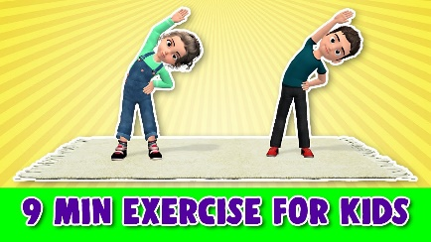
Little sports home exercise
- Core
- Balance
- Stamina
- Legs and Arms



Patty Shukla jump videos



Debbie Doo

Children’s Centre
Canolfan I Blant
Paediatric Physiotherapy Department
St David’s Hospital Ysbyty Dewi Sant
Cardiff
CF11 9XB

Tel: 02921 836802

Cowbridge Road East Cowbridge Road East
Canton Treganna
Cardiff Caerdydd
CF11 9XB CF11 9XB
Phone 029 20536802 FfÔn 029 2053 6802
Fax 029 2053 6779 Ffacs 029 2053 6779

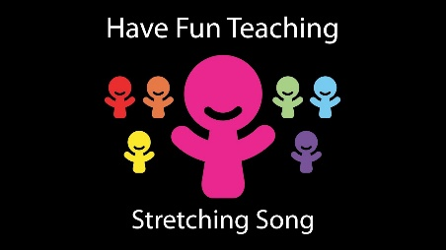
Have fun teaching (instruction video)
- Hopping
- Skipping
- Jumping
- Stretching
- Walking

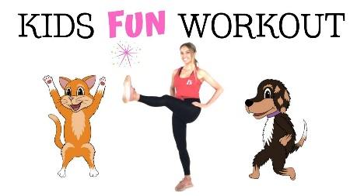
Lucy Wyndham-read for kids


Jump start Jonny

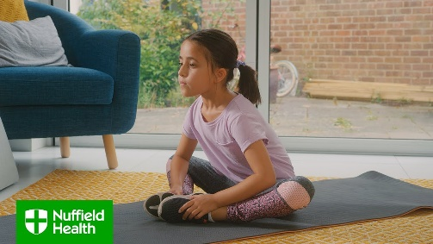
Nuffield Health home exercise for kids.

