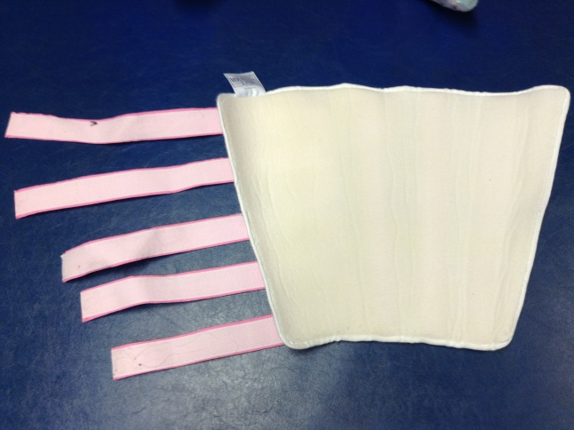
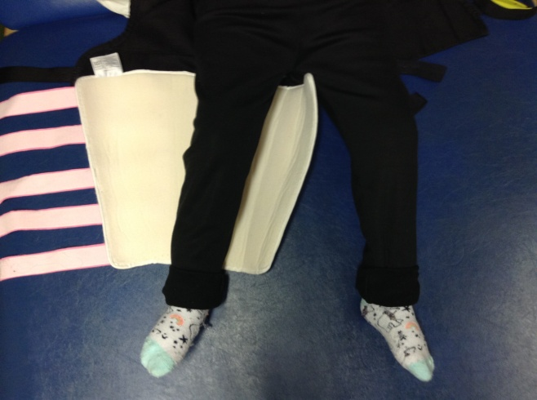

1.
Open gaiter, check left and right on label.
2.
Place gaiter under leg, ensure it is not too high or low.

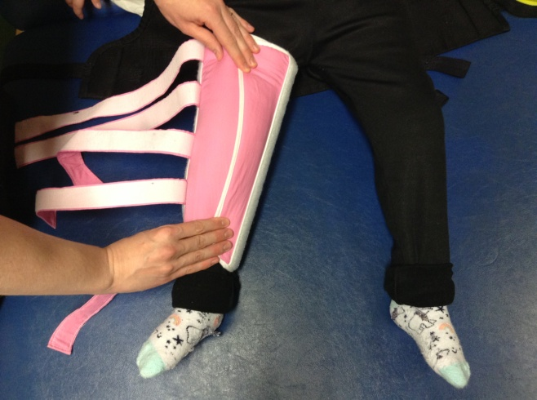
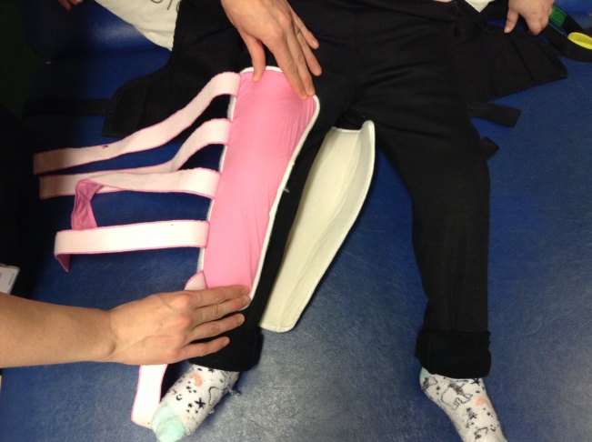

4.
Fold inner side over the top to cover leg.
3.
Fold soft outer side over to cover front of leg.

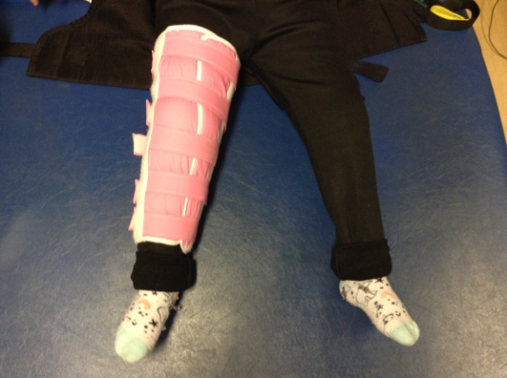
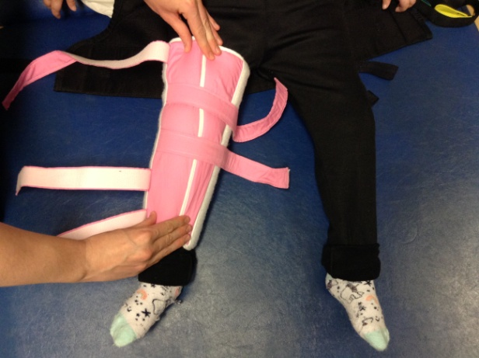

6.
Secure all straps. Ensure tight enough that knee cannot be bent/moved within gaiter
5.
Secure with two Velcro straps – begin with those around the knee.

