
Children’s Centre
Canolfan I Blant
Paediatric Physiotherapy Department
St David’s Hospital Ysbyty Dewi Sant
Cardiff
CF11 9XB

Tel: 02921 836802

Cowbridge Road East Cowbridge Road East
Canton Treganna
Cardiff Caerdydd
CF11 9XB CF11 9XB
Phone 029 20536802 FfÔn 029 2053 6802
Fax 029 2053 6779 Ffacs 029 2053 6779

Fun and easy exercise ideas to do at home 0-5years
*It is important to always have adult supervision whilst carrying out the following games*

Hopscotch
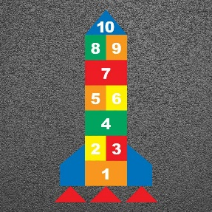

Hula Hoop games – You can jump in and out of them, play throw and catch, squat games


Obstacle course
You can use make an obstacle course indoors using cushions and walking across them, stepping over them, climbing up and down a chair or step, jumping up and down, walking along a line and tandem walking to keep your balance.
Outside you can use the garden furniture to climb up and down, crawl, jump, run step up and down.


Children’s Centre
Canolfan I Blant
Paediatric Physiotherapy Department
St David’s Hospital Ysbyty Dewi Sant
Cardiff
CF11 9XB

Tel: 02921 836802

Cowbridge Road East Cowbridge Road East
Canton Treganna
Cardiff Caerdydd
CF11 9XB CF11 9XB
Phone 029 20536802 FfÔn 029 2053 6802
Fax 029 2053 6779 Ffacs 029 2053 6779

Ball Games
Some ideas may include throw and catch, football, bouncing balls, skittles.


Bubble play
Playing with bubbles is always fun, try sitting jumping and reaching to pop the bubbles to all different directions.


Bunny Hops
Hop like a bunny, making sure that your push off using your hands and feet, and land with both feet together, have a competition to see who can jump the furthest.


