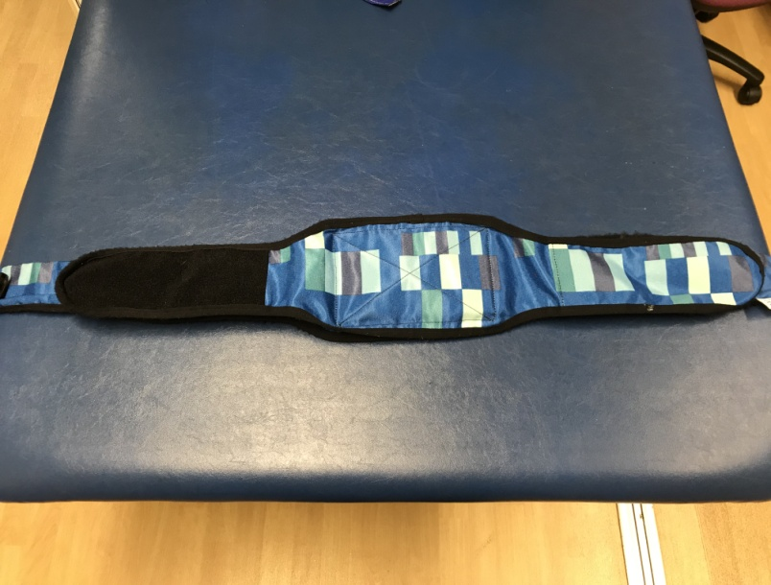
Standing Frame Instructions – Leckey Prone

- The belt must be fastened around the child’s waist before they go into the standing frame. This can be done in lying or sitting.

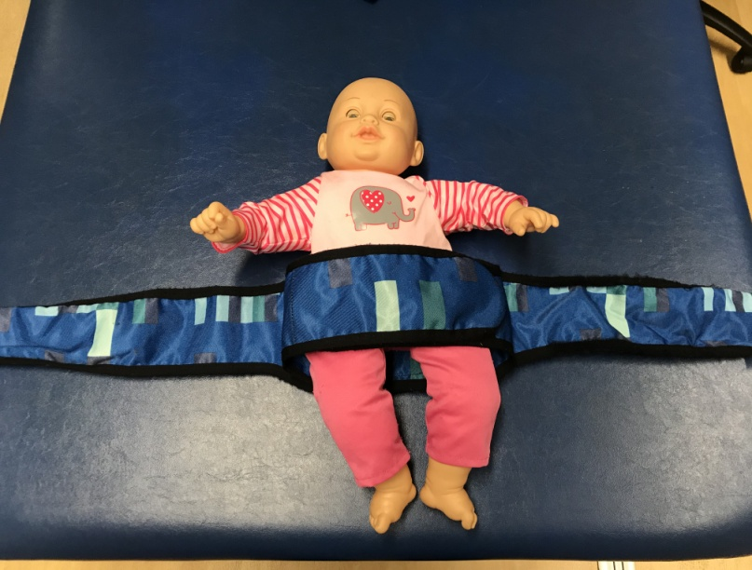

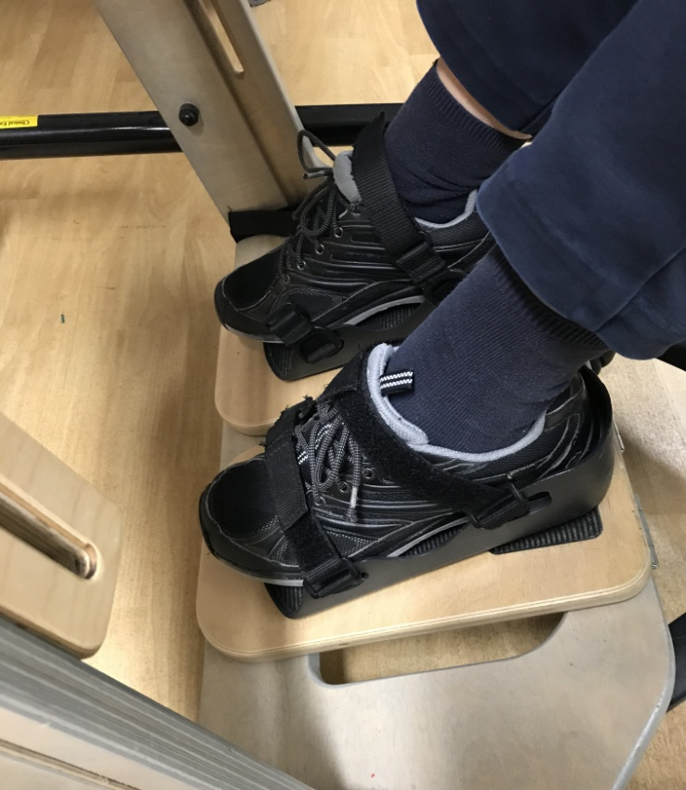

- Have the child either in their wheelchair, or sat on your lap. Place the feet into the footplate and do up the straps

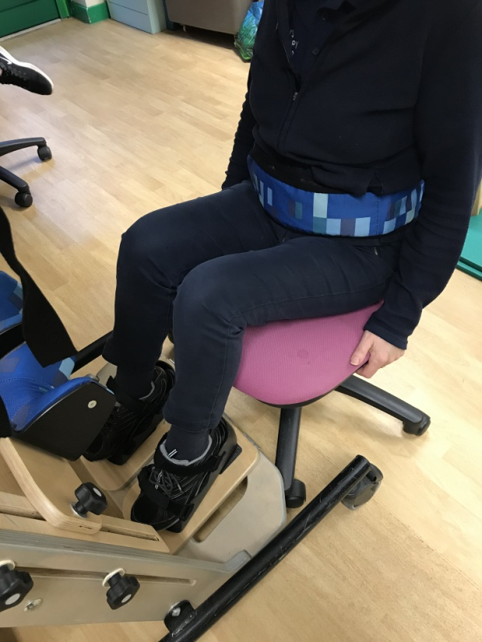
- Belt fastened around the waist & feet strapped in

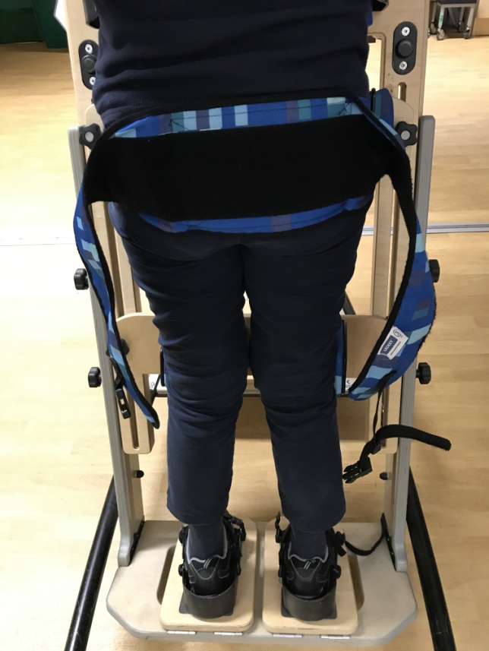
- Stand the child up into the frame, ensuring to support their bottom fully until the straps are done up

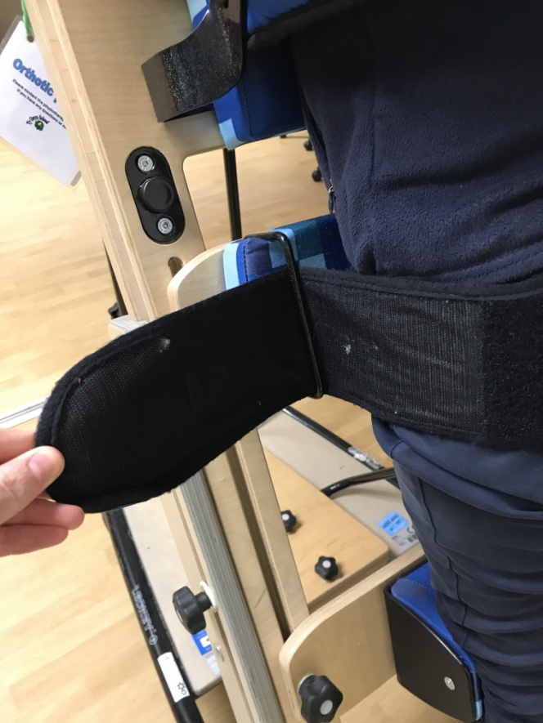

- Feed the outside straps of the belt through the loops at the side of the pelvic support

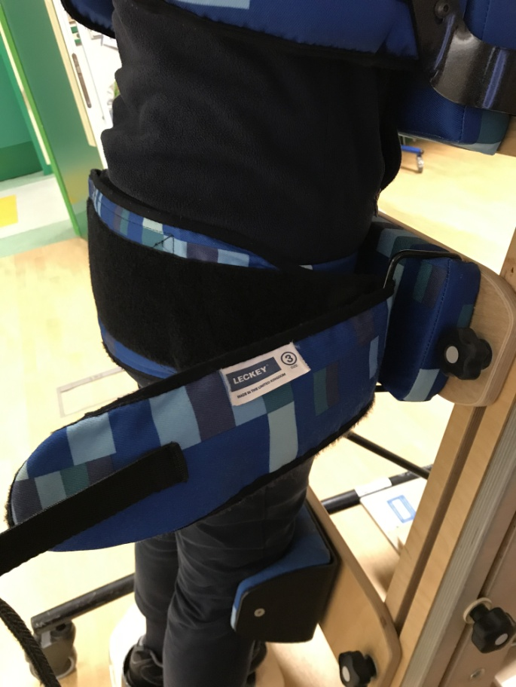
- Feed the outside straps of the belt through the loops at the side of the pelvic support

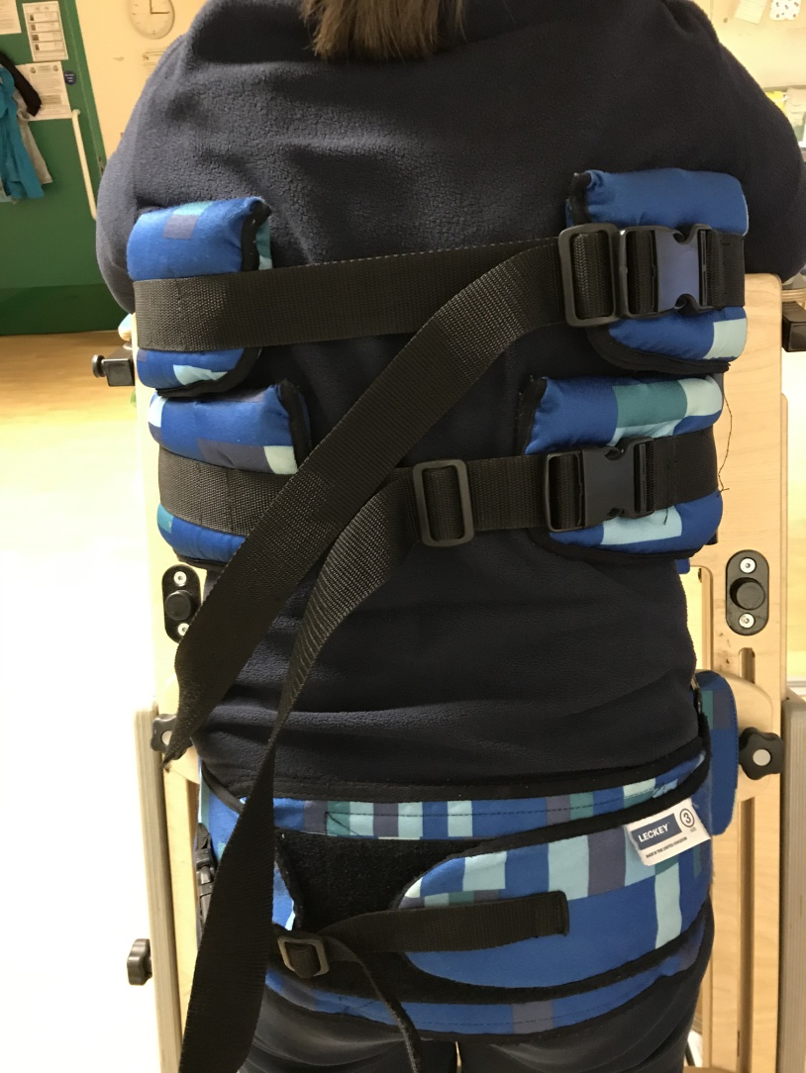
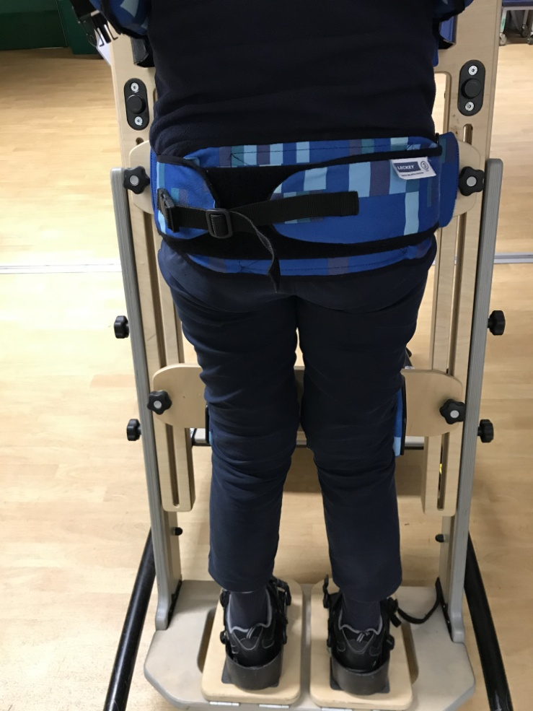
- Pull the outside straps tight and Velcro them together so the pelvis is tight against the frame. Do up the clip.

- Do up the top strap clips (on smaller frames there is only 1 of these)

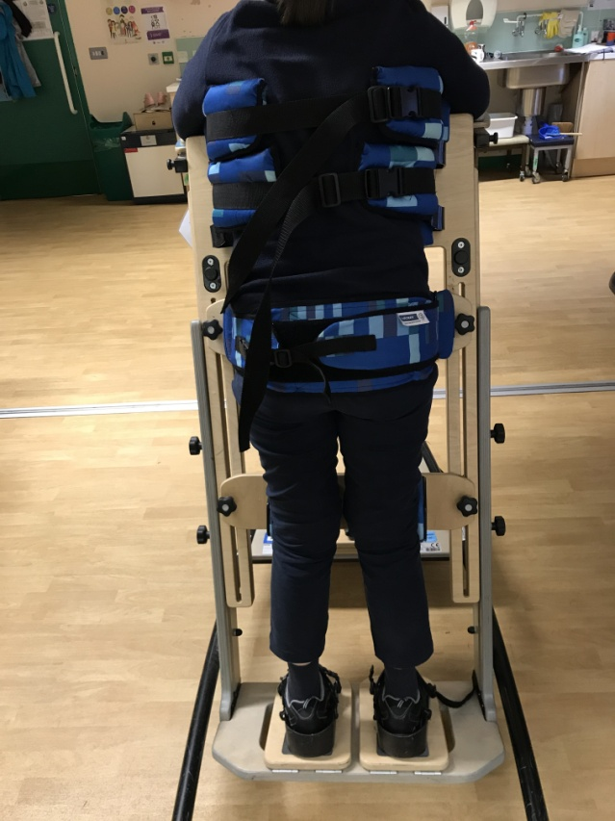
- Once in standing, the body should be straight and tight against the frame. The legs should be as straight as possible and the child should be well supported

- Your child can stand for as long as they can tolerate, we usually suggest starting at 30 mins and building up to an hour at a time. They should stand at least once every day



