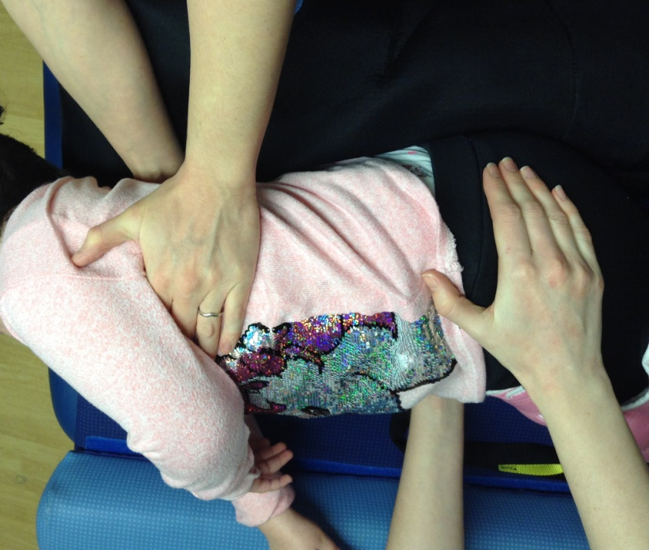
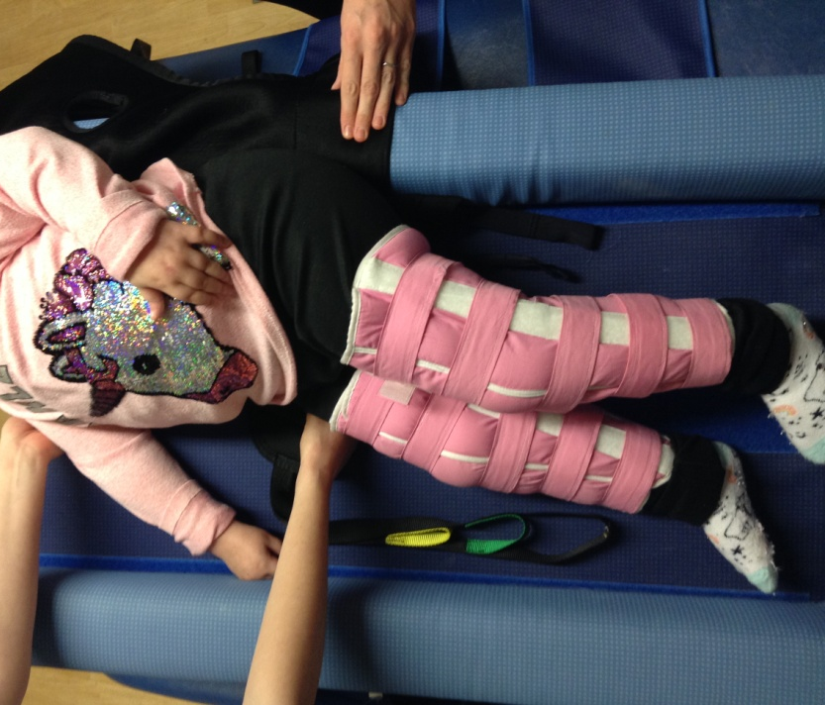
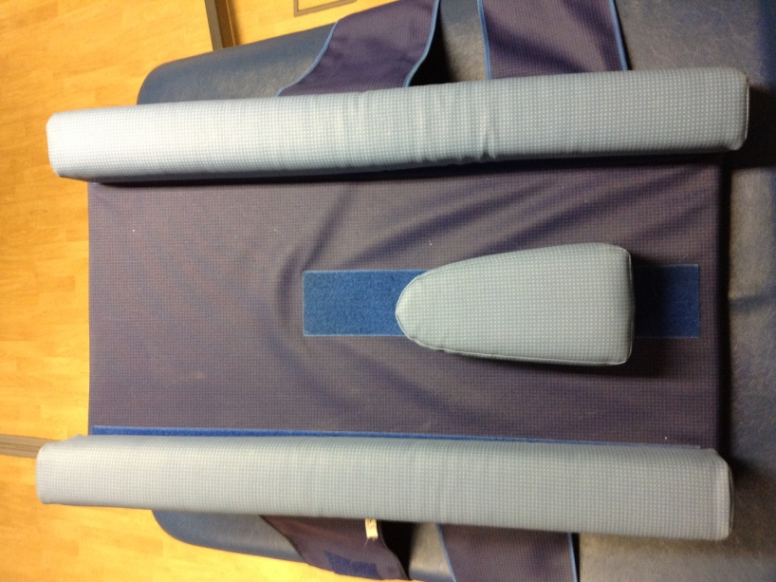
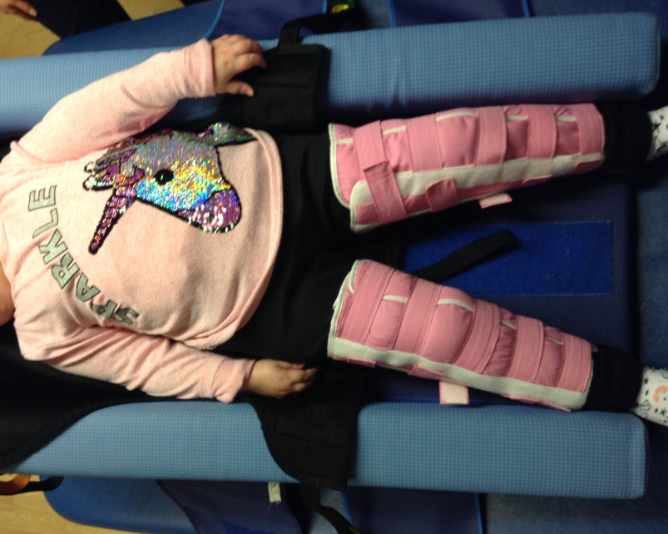

Position on back first

Suggested hand holds for rolling side to front.
Support at chest and pelvis
Assist into side lying

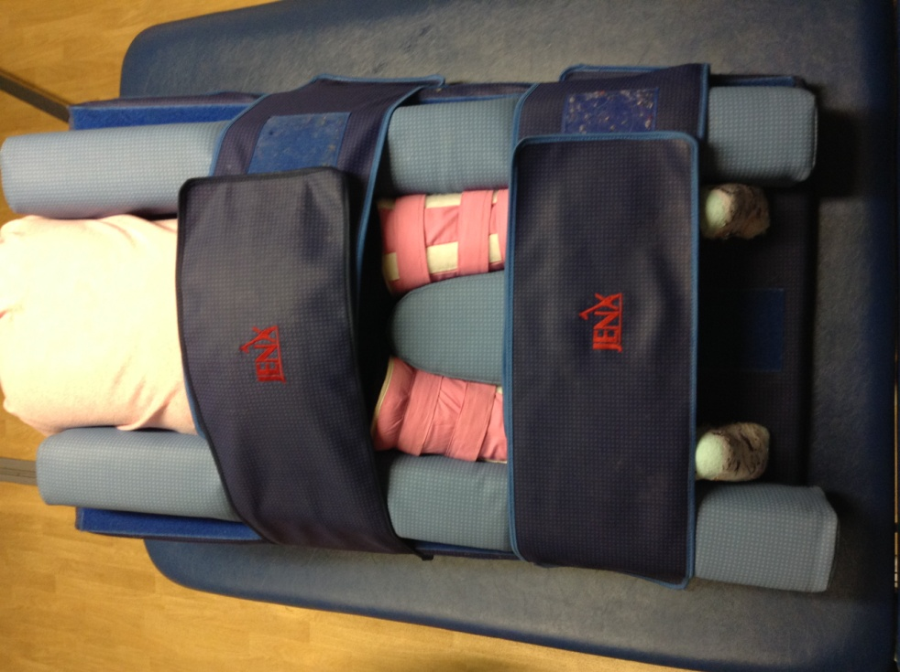
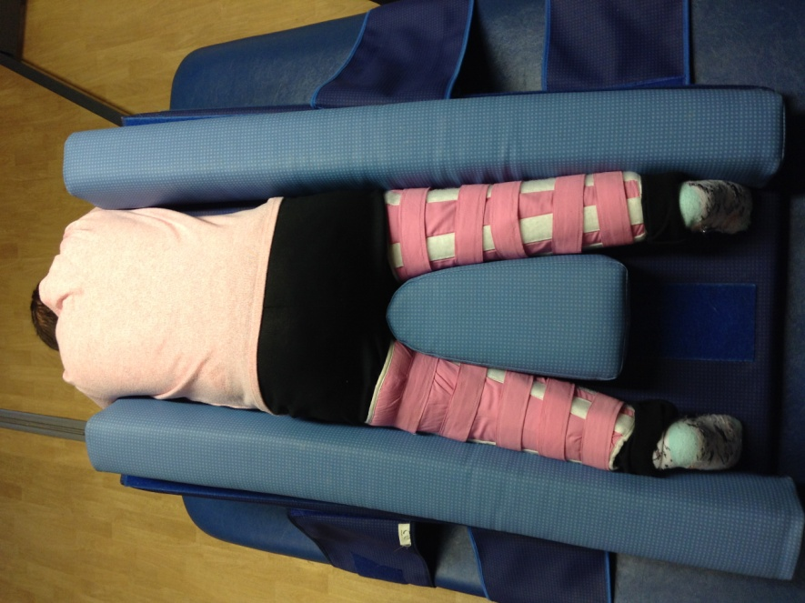
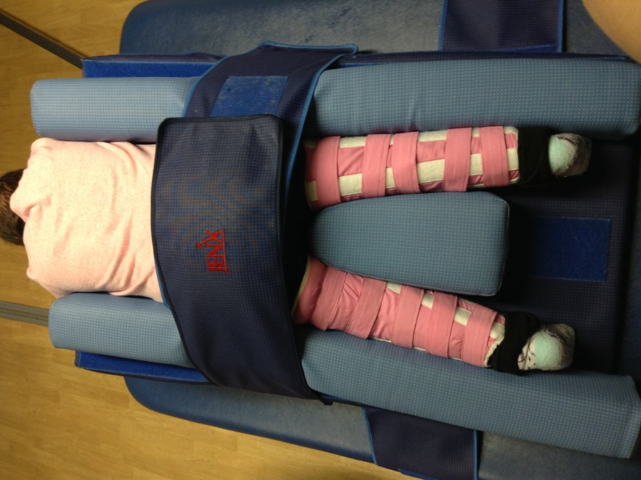
Secure with second strap over calves/ankles
Place block between legs to prevent sliding down
Your child can go on the wedge with or without their gaiters on (if they have them) for up to 1 hour at a time.
Secure safely with belt over pelvis

